**UNITE**

**[U**sing **N**atural resources **I**n **T**he most **E**ffective manner]

**Software Engineering (CSE3001)**

**Review - 3**

*by*

# Patel Pushpam Virenbhai – 17BCE0291

# Patel Yash Vijaykumar- 17BCE0335

**Under the guidance of**

**Dr. Shashank Mouli Satapathy**

### SCOPE

### VIT, Vellore.



April, 2019

DECLARATION BY THE CANDIDATE

We hereby declare that the project report entitled “UNITE

[Using Natural resources In The most Effective manner]” submitted by us to Vellore Institute of Technology, Vellore in partial fulfilment of the requirement for the award of the degree of **B. Tech (CSE)** is a record of J- component of project work carried out by us under the guidance of **Dr. Shashank Mouli Satapathy**. We further declare that the work reported in this project has not been submitted and will not be submitted, either in part or in full, for the award of any other degree or diploma in this institute or any other institute or university.

Place : Vellore Institute of Technology, Vellore.

Date : 08-04-2019

Signature of the faculty Signature of the Candidates

LIST OF FIGURES

FIGURE NO FIGURE TITLE PAGE NO

1 WORK BREAKDOWN STRUCTURE 12

2 PERT CHART 14

3 GANTT CHART 16

4 ER DIAGRAM 21

5 LEVEL 0 DFD 22

6 LEVEL 1 DFD 22

7 LEVEL 2 DFD 23

8 STRUCTURE CHART 25

9 USE CASE DIAGRAM 26

10 ACTIVITY DIAGRAM 36

11 CLASS DIAGRAM 37

12 CRC CARDS 38

13 STATECHART DIAGRAM 41

14 SEQUENCE DIAGRAM 42

15 COLLABORATION DIAGRAM 43

16 COMPONENT DIAGRAM 44

17 DEPLOYMENT DIAGRAM 44

18 DASHBOARD HOME 51

19 DASHBOARD (FILTERED FOR INTER-CITY TRIPS) 52

20 DASHBOARD (FILTERED FOR INTRA-CITY TRIPS) 52

21-32 USER MANUAL (OUTPUT PHOTOS) 53-58

LIST OF TABLES

TABLE NO. TITLE PAGE NO.

1. ACTIVITY NETWORK 13
2. SLACK TIME 15
3. PROJECT RISK ASSESSMENT 16
4. RISK ASSESSMENT 18
5. USE CASE TEMPLATES 27
6. TEST CASE TEMPLATES 45

CONTENTS

PAGE NO:

1 INTRODUCTION

1.1 DOCUMENT PURPOSE 5

1.2 PRODUCT SCOPE 5

1.3 INTENDED AUDIENCE AND DOCUMENT OVERVIEW 5

1.4 DEFINITIONS, ACRONYMS AND ABBREVIATIONS 5

1.5 DOCUMENT CONVENTIONS 5

1.6 REFERENCES AND ACKNOWLEDGMENTS 5

2 OVERALL DESCRIPTION

2.1 PRODUCT PERSPECTIVE 6

2.2 PRODUCT FUNCTIONALITY 6

2.3 USERS AND CHARACTERISTICS 6

2.4 OPERATING ENVIRONMENT 6

2.5 DESIGN AND IMPLEMENTATION CONSTRAINTS 6

2.6 USER DOCUMENTATION 6

2.7 ASSUMPTIONS AND DEPENDENCIES 7

3 SPECIFIC REQUIREMENTS

3.1 EXTERNAL INTERFACE REQUIREMENTS 7

3.2 FUNCTIONAL REQUIREMENTS 7

4 OTHER NON-FUNCTIONAL REQUIREMENTS

4.1 PERFORMANCE REQUIREMENTS 10

4.2 SAFETY AND SECURITY REQUIREMENTS 10

4.3 SOFTWARE QUALITY ATTRIBUTES 10

5 SOFTWARE DESIGN

5.1 DESIGN DIAGRAMS 12

5.2 RISK ASSESSMENT 16

5.3 UML DIAGRAMS 26

6 TEST CASES 45

7 HELP MANUAL (SCREENSHOTS) 53

1. INTRODUCTION
   1. Document Purpose

The purpose of this document is to present a detailed description of the UNITE (Cab Sharing and Transportation Web App). It will explain the purpose and features of the system, the interfaces of the system, what the system will do, the constraints under which it must operate and how the system will react to external stimuli. This document is for both the stakeholders and developers of the Web App.

* 1. Product Scope

Using this application, if a person is travelling by his own car and he has certain seats empty and wants to help someone, in return for some money, he can register himself in his application. Then when a hitchhiker places a request for getting nearest transport, he'll be able to see all the people travelling with their cars nearby to him and he can see the path on which they are travelling. Then he can place a request to those people, and then a person picks him up with his car and then drops him off to his desired location.

There will also be a ** security feature ** in this application

* 1. Intended Audience and Document Overview

The intended audience for this document are both the stakeholders and the members from the development team.

The Document contains the Software Requirement Specifications about the project UNITE starting from Product Description to Product Requirements.

It is advisable to read the document in the published order so that no discrepancies’ arise.

* 1. Definition, Acronyms and Abbreviations

Stake Holder: A person with an interest or concern in something, especially a business.

Driver: User who wants to find passenger for his car.

Passenger: User who is looking for a cab.

* 1. Document Conventions

This Document follows IEEE standards of the SRS Document.

All fonts are in Times New Roman.

* 1. References and Acknowledgement
* IEEE. *IEEE Std 830-1998 IEEE Recommended Practice for Software Requirements Specifications.* IEEE Computer Society, 1998.

1. OVERALL DESCRIPTION
   1. Product Perspective

The following Web App is newly developed based on the product review of the existing system available for the same purpose of Cab sharing and availability of a way to book various mode of transportation from a single application. The developed product is designed for the major purpose of Cab sharing system but in case if there are no cabs available, the system is functioned to find an alternative mode of transport to destination on user selection of mode of transport.

* 1. Product Functionality
* During Login Aadhaar card number is taken for verification of user and the one time password is used to verify the of the user.
* Driver posting request to join his car and entering the details of car: car name, mileage and number of seats available.
* Passenger can see the available cars on entering the start and end location of his journey, And request the driver,
* Driver on the other end can accept his request.
* We are using e-wallet for payments and user can add money to wallet according to his need.
* If there is no availability of cab at that location then we can also provide them the feature to see nearest public transports like Bus or Train to make their journey cheaper and easier.
  1. User Characteristics

There are various type of users but the frequency would be far higher in city and on the route of national and state highway as there are more frequency of people travelling in that route thus making easy availability of the cab.

* 1. Operating Environment

The developed system is an online web app thus a web browser is a basic operating tool required. There must be availability of current location and permission shall not be denied to access location or the there would be no more progress towards the booking.

* 1. Design and Implementation Constraint
* Internet access is required for usage of Web app and for payment.
* Location access is required.
* Automatic calculation of fare
  1. User Documentation
* User Help Documentations with explanation with help of photos is available.
  1. Assumptions and Dependencies
* Google Location
* Heroku Server
* MongoDB Database
* Posting request for cab once.

1. SPECIFIC REQUIREMENETS
   1. External Interface Requirements
      1. User Interfaces

The user interface shall follow basic Windows style and functionality conventions.

Home screen will have option for login and registration for every user and nce after login there would be 3 options. Three option would be to become a driver, consider oneself as passenger, or add money to wallet for payment.

* + 1. Hardware Interfaces

As such no specific hardware interface is required. The software can be used in any personal computer having windows 2000 and above with more than 100MB of memory available and sufficient resources to access web beowser and active internet connection.

* + 1. Software Interfaces

Login and Registration is must for the usage of the application and thus email verification is needed to enter the application. Once logged in there are option available and for every step ahead, there are data processed in database.

Database and Interface are connected and if connection had issued the service would be interrupted.

* + 1. Communication Interfaces

Communication would be carried out using heroku server. There is also usage of email, as verification would be sent of email and with the payment API.

* 1. Functional Requirements

1. **REGISTRATION USING ADHAAR CARD and ONE TIME PASSWORD VERIFICATION**

1.1 *SELECT REGISTER FROM HOME PAGE*

**INPUT**: CLICK ON LOGIN

**OUTPUT**: REDIRECT TO LOGIN PAGE

1.*2 FILL THE DETAILS IN LOGIN PAGE*

**INPUT**: FIRST NAME, LAST NAME, EMAIL ID, ADHAAR CARD, MOBILE NUMBER, PASSWORD

**OUTPUT:** REDIRECT FOR OTP VERIFICATION

1.3 *ENTER THE OTP*

**INPUT:** ENTER OTP

**OUTPUT**: REDIRECT TO BOOKING HOME PAGE

**PROCESSING** : VERIFY OTP

1. **DRIVER POSTING REQUEST**

**2.1 ENTER DETAILS**

**INPUT:** SOURCE, DESTINATION, CAR NAME, CSAR NUMBER, TIME, MAX SEATS

**OUTPUT:** POSTING THE REQUEST

**2.2 GET ACCESS TO LOCATION AND TAP START BUTTON**

**INPUT:** TAP START BUTTON

**OUTPUT:** CURRENT LOCATION IS RECORDED FOR JOURNEY

1. **PASSENGER CAN SEE DETAILS OF CARS AVAILABLE ON ROUTE ON ENTERING THE START AND END LOCATION** 
   1. *ENTER JOURNEY DETAILS*

**INPUT:** ENTER SOURCE, DESTINATION, TIME

**OUTPUT:** REQUEST HAS BEEN POSTED

* 1. *SELECT STATUS*

**INPUT:** SELECT STATUS ON HOME PAGE

**OUTPUT:** REDIRECT TO STATUS PAGE

* 1. *CHOOSE CAR*

**INPUT :** CLICK ON THE CAR YOU WANT TO TRAVEL FROM THE AVAILABLE CAR FOR THAT ROUTE

**OUTPUT**: THE REQUEST HAS BEEN SEND SELECTED DRIVER

1. **DRIVER ACCEPTING REQUEST** 
   1. *SELECT STATUS*

**INPUT:** SELECT STATUS ON HOME PAGE

**OUTPUT:** REDIRECT TO STATUS PAGE

4.2 *ACCEPT THE REQUEST*

**INPUT** : SELECT THE PASSENGER WANTED IF NOT REJECT

**OUTPUT**: STATUS OF BOTH DRIVER AND THE PASSENEGR IS UPDATED

1. **ADD MONEY TO E-WALLET** 
   1. *SELECT WALLET*

**INPUT:** CHOOSE THE TRANSECTION OPTION

**OUTPUT:** MONEY ADDED

1. **CHOOSING OTHER OPTIONS ON NOT AVAILABILITY OF CAR** 
   1. *SELECT OTHER OPTION*

**INPUT:** CLICK ON OTHER OPTION

**OUTPUT**: REDIRECT TO OTHER PAGE

* 1. *GETTING ALTERNATIVE PATH*

**INPUT:** ENTER START AND END LOCATION

**OUTPUT**: GET THE ALTERNATIVE PATH THROUGH BUS OR SOME OTHER TRANSPORT

1. OTHER NON-FUNCTIONAL REQUIREMENTS
   1. Performance Requirements

Performance requirements define acceptable response times for system functionality.

* The load time for user interface screens should be fast.
* The log in information shall be verified within five seconds.
* Queries shall return results within five seconds.
* The Time In Which The Link Shall Open Should Be Between 5 Secs To 1 Min
* For A Feasible Operation.
* Login Verification Time Should Be 1-5 Secs.
* Maximum Latency Of Queries Being Opened Must Be Between 5-30 Secs
* If The Max Time Is Crossed Must Show Appropriate Message.
  1. Safety and Security Requirements

Safety requirement are taken care while taking the input of registration for the user.

Adhaar card details and also email verification used so to reduce the usage of accounts or details of some other person.

* 1. Software Quality Attributes
     1. Availability

The system shall be available 24x7 because a transportation never shuts down. On serious occasions of emergency or disaster ,the system may have a provision towards working even faster to ensure availability.

4.3.2 Maintainability

Maintainability Website is developed and a database is maintained. UNITE system is a software based system only. It works on the information accessible given in the software and requires the accessibility of databases and uninterrupted servers.

**SOFTWARE DESIGN DOCUMENT**

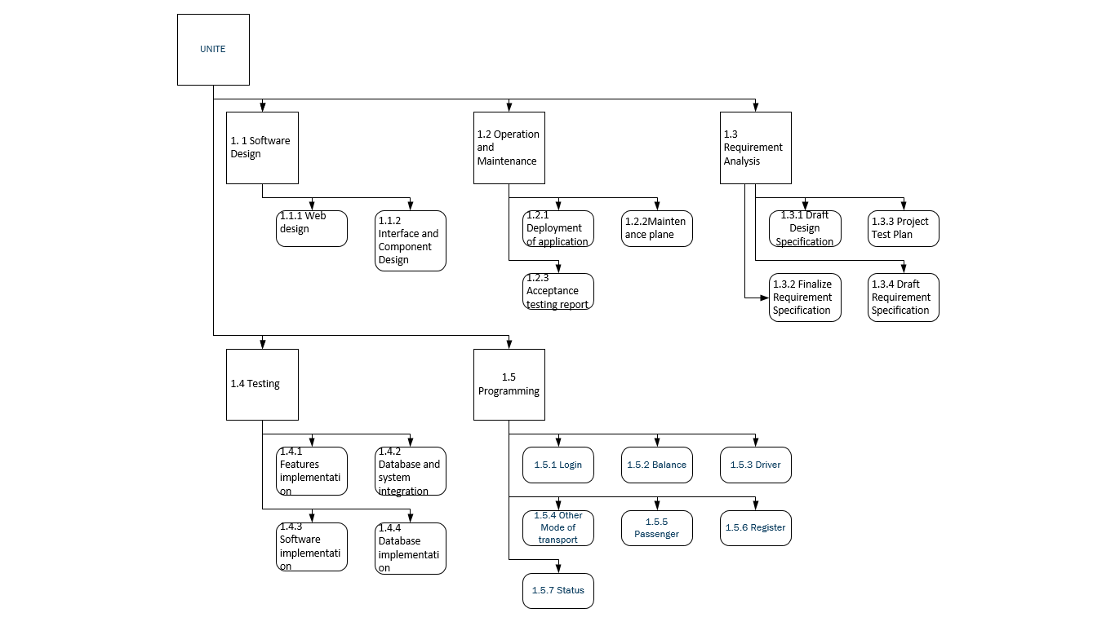

**FIGURE 1: WORK BREAKDOWN STRUCTURE**

**DELIVERABLES**

* REQUIREMENTS SPECIFICATION – 2ND WEEK OF DECEMBER
* UML DIAGRAMS – 1ST WEEK OF FEBRUARY
* SYSTEM DESIGN – 2ND WEEK OF FEBRUARY
* ANALYSIS OF TECHNICAL REQUIREMENT - 2ND WEEK OF FEBRUARY
* SOFTWARE DEVELOPMENT(50 PERCENT) - 3RD WEEK OF FEBRUARY
* TEST CASES – 2ND WEEK OF MARCH
* FINAL SRS DOCUMENT – 3RD WEEK OF MARCH

**TABLE 1: ACTIVITY NETWORK**

|  |  |  |  |
| --- | --- | --- | --- |
| Activity | Description | Immediate Predecessors | Estimated Time  (day’s) |
| A | Set up the project acquisition team and decide the title of the project | - | 10 |
| B | Determine of user needs, and environmental issues | A | 5 |
| C | Write down the software requirement | B | 7 |
| D | Benchmark studies and determine the proper layout | C | 5 |
| E | Identifying you target users and prepare the functional specification | D | 10 |
| F | Create your Business model such that both customers and we get profit from it | E | 8 |
| G | Learning how to make a front-end of your web application | F | 12 |
| H | Creating front-end according to the layout decided and testing | F | 10 |
| I | Learning how to create a back-end for web application | G, H | 12 |
| J | Creating a back-end for your web application and testing | I | 12 |
| K | Learning how to make server connection | J | 10 |
| L | Create a server connection | J | 8 |
| M | Getting proper Api keys request and Payment gateway | K, L | 5 |
| N | Testing of the complete website | M | 5 |
| O | Proper Documentation to be prepared, describing the complete motive of the application | N | 7 |
| P | Software deployment and project sign-off | O | 5 |

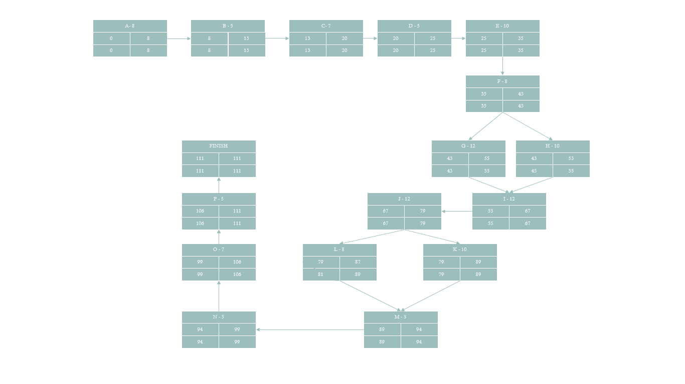

**FIGURE 2: PERT CHART**

|  |  |  |  |  |  |
| --- | --- | --- | --- | --- | --- |
| PROCESS | ES | EF | LS | LF | SLACK TIME |
| A | 0 | 8 | 0 | 8 | 0 |
| B | 8 | 13 | 8 | 13 | 0 |
| C | 13 | 20 | 13 | 20 | 0 |
| D | 20 | 25 | 20 | 25 | 0 |
| E | 25 | 35 | 25 | 35 | 0 |
| F | 35 | 43 | 35 | 43 | 0 |
| G | 43 | 55 | 43 | 55 | 0 |
| H | 43 | 53 | 45 | 55 | 2 |
| I | 55 | 67 | 55 | 67 | 0 |
| J | 67 | 79 | 67 | 79 | 0 |
| K | 79 | 89 | 79 | 89 | 0 |
| L | 79 | 87 | 81 | 89 | 2 |
| M | 89 | 94 | 89 | 94 | 0 |
| N | 94 | 99 | 94 | 99 | 0 |
| O | 99 | 106 | 99 | 106 | 0 |
| P | 106 | 111 | 106 | 111 | 0 |

**TABLE 2 : SLACK TIME**

**CRITICAL PATH**

A-B-C-D-E-F-G-I-J-K-M-N-O-P

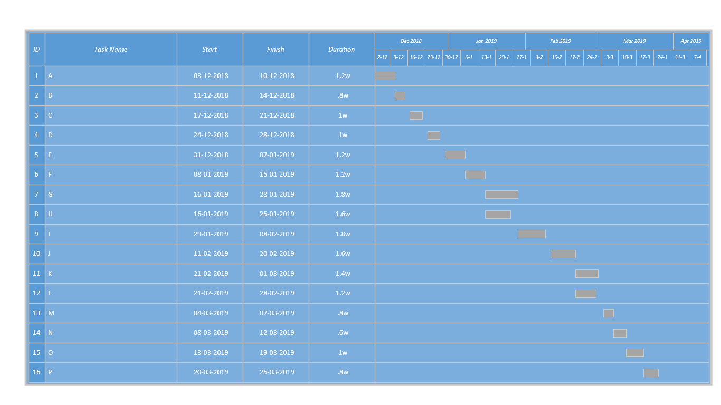

**FIGURE 3: GANTT CHART**

|  |  |  |  |
| --- | --- | --- | --- |
|  | **TABLE 3 : PROJECT RISK ASSESSMENT** |  |  |
|  |  |  |  |
|  | **Project Name: UNITE** | **Project Size:** | **2** |
|  | **Project Manager: 220** | **Date: 31-01-2019** | |
|  | **Risk Score:** | **Risk Rating:** | **MEDIUM** |
|  |  |  |  |
|  | **Project Risk Score & Risk Rating Guidelines** |  |  |
|  | 0 to 110: LOW RISK |  |  |
|  | 115 to 290: MEDIUM RISK |  |  |
|  | 300 or higher: HIGH RISK |  |  |
|  |  |  |  |
|  | The Project Risk Assessment is a self-evaluation of the project risks by identifying activities that typically represent risk. By completing this worksheet at the time of Project Origination, you can provide additional information that is relevant to understand the potential impacts this effort might have.   Review each question below and assign a risk rating of 0-40 based on the most relevant risk category item and its relevance to your project. **Risk scores of 30 or 40 must be explained in the Comments column; these specific risks must then be documented with a risk mitigation plan in the Project Charter or Project Management Plan.**   If you have any questions about completing this document, please contact the PMO (Bill Kanfield kanfi001@umn.edu or 612-626-4223). | | |
|  |  |  |  |
| **#** | **Risk Category** | **Score** | **Comments** |
| **BUSINESS RISK** | | **85** | **N/A** |
| **1** | **Implementation complexity and impact to processes and business areas:** | **25** |  |
|  | - Implementation is not complex | 0 |  |
| - Implementation is complex, though team has prior experience | 0 |
| - Implementation is complex with many areas impacted and new methods introduced | 25 |
| **2** | **Business Dependencies that might impact implementation:** | **20** |  |
|  | - No impact, No business dependencies exist | 0 |  |
| - Yes, some business dependencies exist but are low risk | 0 |
| - Yes, there are key business dependencies that might impact project implementation | 20 |
| **3** | **Outages required during the implementation:** | **40** |  |
|  | - None required | 0 | AS THE PROJECT HAS 24 HOURS RUN TIME WE DON’T HAVE ANY AFTER BUISNESS HOUR. |
| - Outages to be planned after business hours | 0 |
| - Outages to be planned during business hours | 40 |
| **TECHNOLOGY RISK** | | **100** | **N/A** |
| **4** | **Type of Project:** | **25** |  |
|  | - Maintenance (e.g., correct problems) | 0 |  |
| - Enhancement (e.g., add new features) | 0 |
| - Product introduction | 0 |
| - Process improvement/re-engineering | 0 |
| - Upgrade existing software or applications | 0 |
| - New development – replace existing system | 0 |
| - New development – develop system to support new business | 25 |
| - Implementation of software package in-house | 0 |
| - Outsourcing to external vendor | 0 |
| **5** | **External Vendor Involvement:** | **10** |  |
|  | - No external or internal vendor required | 0 |  |
| - No, an internal partner will be used for some project activites | 10 |
| - Yes, an existing external vendor will be used | 0 |
| - Yes, a known external vendor will be used but a new contract or PO is required | 0 |
| - Yes, and external vendor is required but not yet identified | 0 |
| **6** | **Level of vendor support necessary for the technology after implementation:** | **15** |  |
|  | - N/A (no vendors involved) | 0 |  |
| - No subsequent vendor support necessary | 0 |
| - Minor support necessary (e.g., maintenance only) | 15 |
| - Major support necessary (e.g., programming, upgrades, etc.) | 0 |
| **7** | **Newness of Technology (hardware, systems, databases, communication, etc.) used in the project:** | **20** |  |
|  | - N/A (no technology involved) | 0 |  |
| - Technology is not new and has been proven or tested | 0 |
| - New to the business line | 20 |
| - New to University Services | 0 |
| - New to the education/learning services industry | 0 |
| **8** | **Availability of Project Team Resources** | **30** |  |
|  | - We have the resources with the appropriate skill sets | 0 |  |
| - We have resources but they will need to be trained | 30 |
| - The project will require external resources | 0 |
| **IMPLEMENTATION RISK** | | **35** | **N/A** |
| **9** | **Will the Office for General Counsel or Purchasing be used during the negotiation, creation, or modification of the contract?** | **15** |  |
|  | - No contract is required for project. | 0 |  |
| - No, the existing contract will be used and no modifications or addendums will be required. | 0 |
| - Yes, the OGC and Purchasing will be highly involved with contract negotiation, creation, or modification. | 0 |
| - Yes, the OGC and Purchasing will be involved, but in a limited capacity | 15 |
| - No, the OGC and Purchasing will not involved with the contract negotiation, creation, or modification. | 0 |
| **10** | **Has the Business Case been developed, reviewed and approved:** | **20** |  |
|  | - Yes, the Business Case/justification is documented and fully approved | 0 |  |
| - Yes, but there are some unknowns or assumptions the business case, stakeholders or product/service deliverables | 20 |
| - No, there are many unknowns or assumptions around the business case, stakeholders, strategy or product/service deliverables | 0 |
| **11** | **Additional project risks not previously addressed 1:** | **0** |  |
|  | - | 0 |  |
| - | 0 |
| - | 0 |
|  | **TOTAL PROJECT RISK SCORE** | **220** | **FINAL PROJECT RISK RATING:  [RATING]** |
|  |  |  |  |
|  | 1 Separately list and rank each additional risk not previously addressed that is unique to your business line, technology used, or project using the following scale:  Low risk = 0-10; Medium risk = 11-20; High risk = 21-40. Add additional lines as needed. | | |
|  |  |  |  |
|  | **Project Risk Score & Risk Rating Guidelines** |  |  |
|  | 0 to 110: LOW RISK |  |  |
|  | 115 to 290: MEDIUM RISK |  |  |
|  | 300 or higher: HIGH RISK |  |  |

|  |  |  |  |  |  |  |  |  |  |
| --- | --- | --- | --- | --- | --- | --- | --- | --- | --- |
| **TABLE 4: Risk Assessment Template - Top Ten Risks** | | | |  |  |  |  |  |  |
|  |  |  |  |  |  |  |  |  |  |
|  | **Risk statement** | | (Scale 1-100%) | (Scale 1-10) |  |  |  |  |  |
| **#** | **Condition** | **Consequence** | **Probability** | **Impact** | **Exposure** | **Mitigation** | **Contingency** | **Triggers** | **Assignee** |
| 1 | Small Team for development. | The project could be delayed. Incorrect decisions could be made. | 90% | 9 | 8.1 | Commitment to the projet. | Prioritize the taskk according to importance | Anytime between start to end of project | Program manager |
| 2 | Possible denial of service attack. | Non-availability of the system to the customers and end users. | 60% | 10 | 6 | Usage of intruder safety technology. | Develop, test, and regularly review recovery procedures. | Start of project | IT manager, network manager |
| 5 | If sales drop, the project budget might be reduced or cancelled. | Project cancellation, delay, or scope reduction. | 50% | 10 | 5 | No action possible within the scope of the project. | Consider deferring some functionality into later phases of the project. | When a change to the project budget is known | Product manager |
| 4 | Location tracing | Ambiguity about the co-ordinates | 60% | 8 | 4.8 | Update to latest version for better accuracy | Retrace and redo the location input. | Customer in clumsy area or Road maybe blocked due to maintenance | Development |
| 6 | Customer data might be incomplete, making analysis difficult. | Reduced ability to analyze customer information to identify best customers. | 60% | 6 | 3.6 | Determine extent of problem and how significant the data is to analysis. | Consider cleaning the data extracted from the customer details system and putting it into Analysis Services. | When a decision is made about the percentage of incomplete data and its impact on the system | Product manager |
| 10 | Marketing | Project could end up in loss | 40% | 9 | 3.6 | Have external agaencies for marketing | Give offers for the new customers | After deployment of project | Program manager |
| 3 | Payment through cash rather than wallet. | Less Profit for the project | 30% | 9 | 2.7 | Only allow payment through wallet | Encourage the customer by giving cashbacks. | After completion of trip. | Product manager |
| 8 | External vendor for maintenance may take back his partnership | The project could be delayed. | 30% | 7 | 2.1 | Verify with external vender management the notice period for their staff. | Verify that external vendor, has other staff available with suitable skills in case any of the staff allocated become unavailable. | Start of project | Project manager / customer |
| 7 | Data updation may not be lightining instant | Decisions could be made on the basis of incomplete information. | 30% | 6 | 1.8 | Schedule updation as soon as possible. | Educate user about the average updation time | Start of project | Development |
| 9 | Not availibility of car | Usage of public transport therefore less profit | 20% | 8 | 1.6 | Proper sales management leading to availibilty of driver. | Public transport usage | Trip Planning | Development |

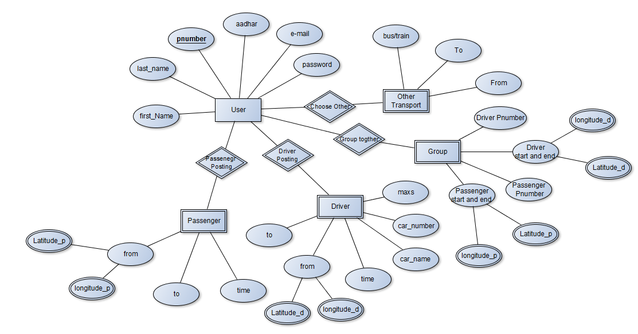

**FIGURE 4: ER DIAGRAM**

* DATA FLOW DIAGRAM

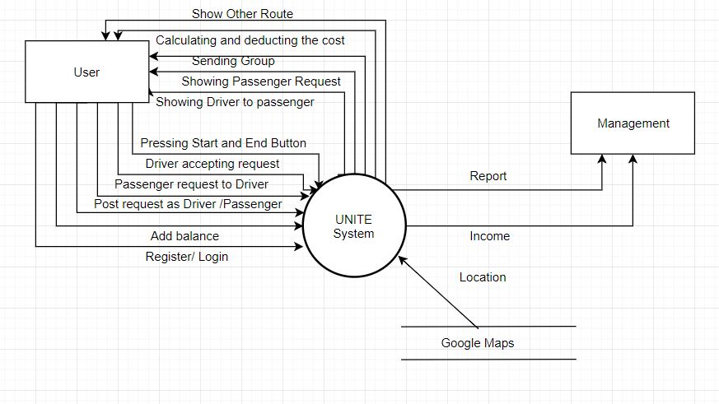

**FIGURE 5: LEVEL 0 DFD**

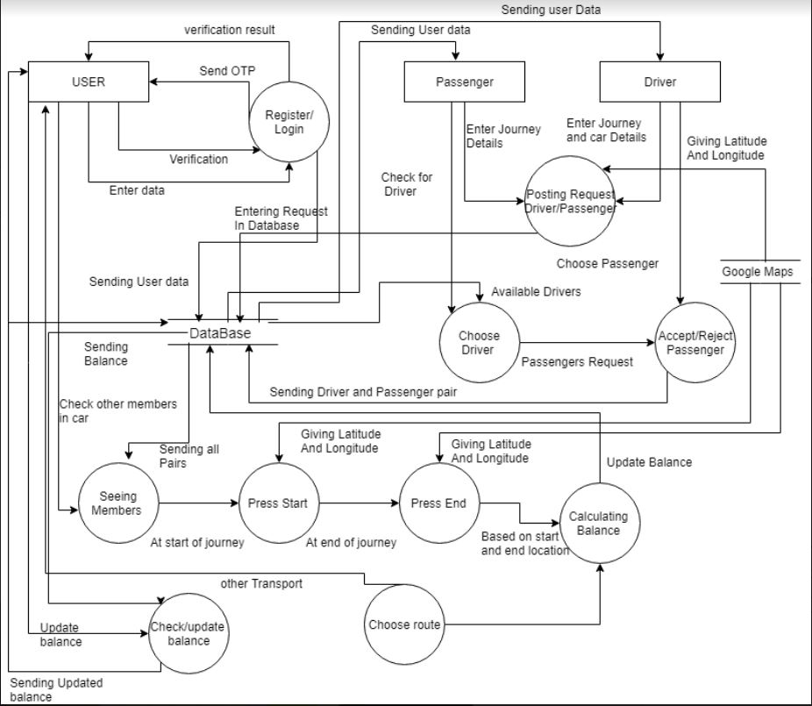

**FIGURE 6: LEVEL 1 DFD**

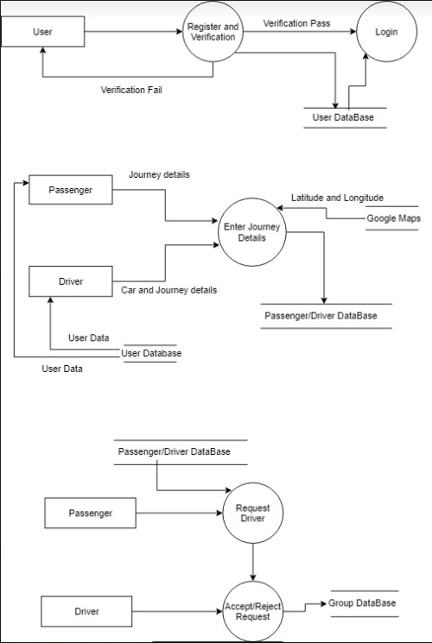

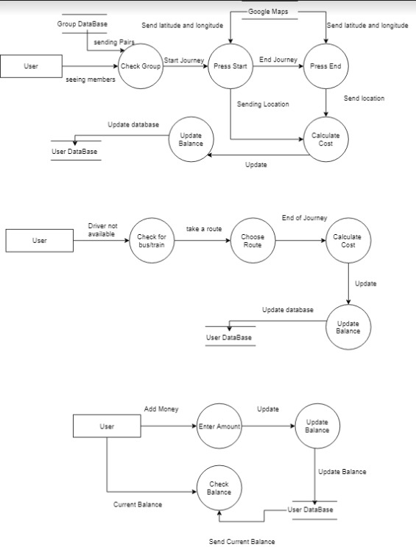

**FIGURE 7: LEVEL 2 DFD**

* DATA DICTIONARY
* First Name: String
* Last Name: String
* Name: First Name + Last Name
* Email: String
* Adhaar Card : Integer
* Mobile no : {Integer} *For OTP Verfication*
* Password: String
* OTP : Integer
* Authentication successful : Correct OTP
* Login Successful : [Valid Username, Valid Password]
* Start Location: {String}
* End Location: {String}
* Car Number : String
* Car Name: String
* Hours: Integer
* Minutes: Integer
* Time : Hours + Minutes
* Max Seats : Integer *Seat available in drivers car*
* Amount : Integer *Balance in wallter*
* Final Fare : {Integer} *Amount customer has to pay*

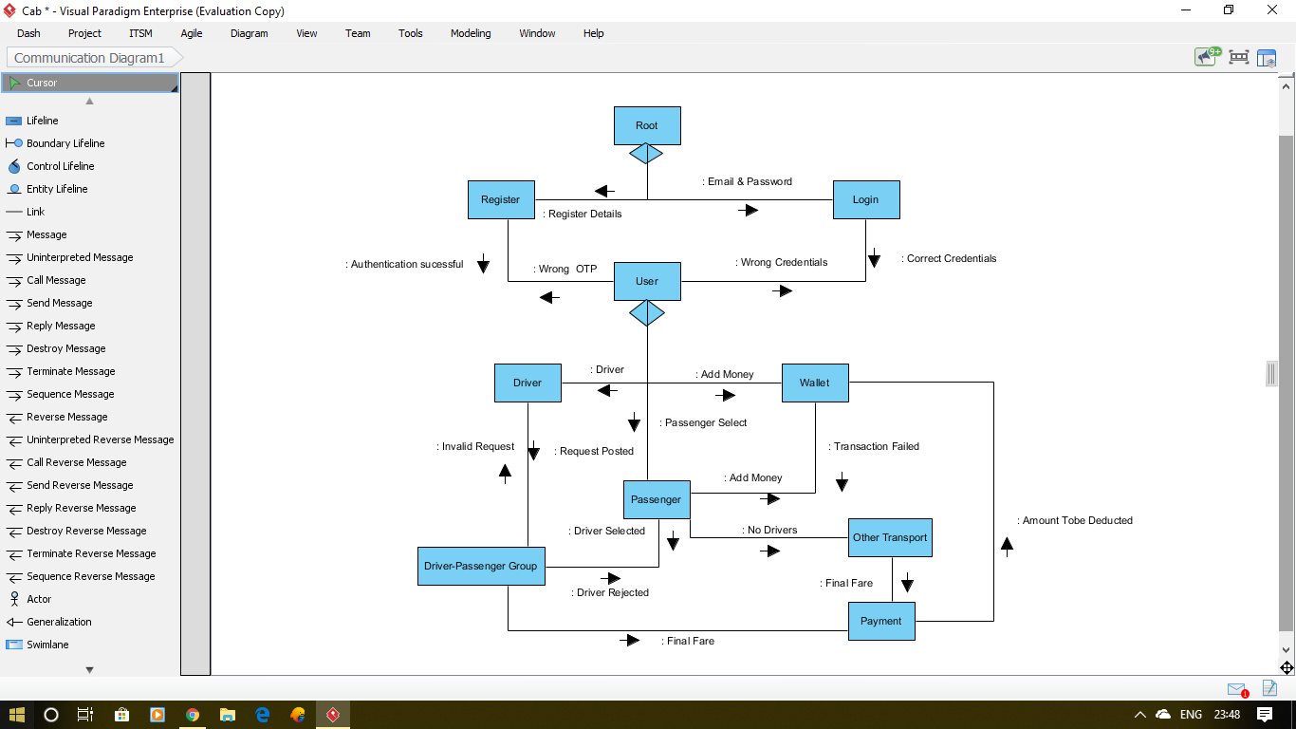

**FIGURE 8: STRUCTURE CHART**

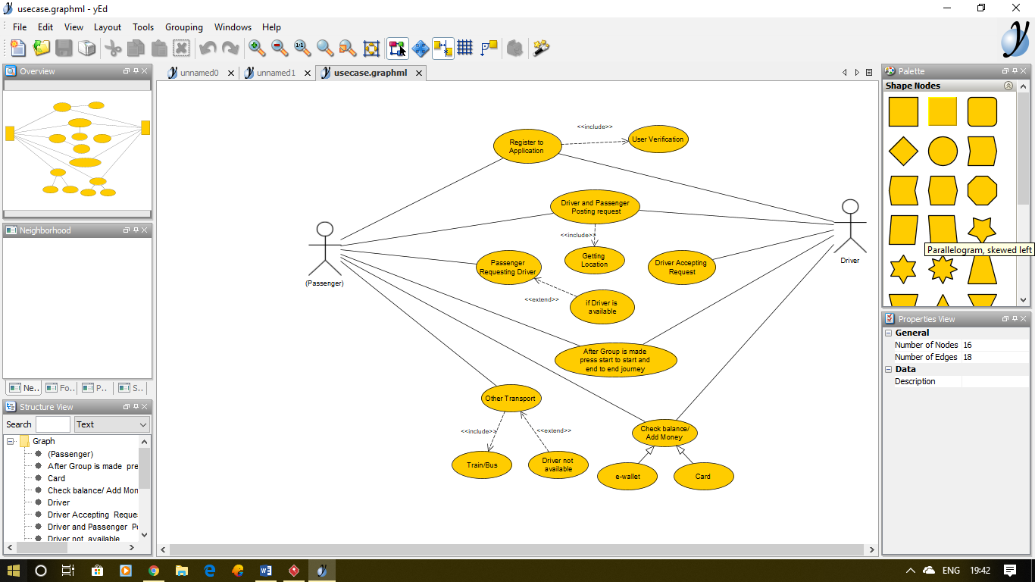

**FIGURE 9: USE CASE DIAGRAM**

TABLE 5: USE CASE TEMPLATES

|  |  |  |  |
| --- | --- | --- | --- |
| Use Case ID: | 100 | | |
| Use Case Name: | Register to Application  <<include>> Verification | | |
| Created By: | YASH PATEL | Last Updated By: |  |
| Date Created: |  | Date Last Updated: |  |

|  |  |
| --- | --- |
| Actor: | Driver and Passenger |
| Description: | Before using the application, user has to provide their details and the details is to be verified |
| Preconditions: | Open application |
| Postconditions: | User has successfully registered and verification is successful.  Is verification fails the go back to home page and ask user to Register again |
| Priority: | High as everyone has to register |
| Frequency of Use: | 100% if new user else 0% (instead login page will be used) |
| Normal Course of Events: | 1.User need to enter all his details  2.Send verification to mail or phone number  3.Verification successful then register  4.If not ask user to register again |
| Alternative Courses: | No alternative as it mandatory to register |
| Exceptions: | 1.User entering wrong Phone number  2.User entering wrong Aadhar Card number  3.OTP does not send on time  4.User entering wrong e-mail |
| Includes: | Complete details of users like name, aadhar card number, phone number, email, password and verification of the details entered |
| Special Requirements: | 1.User must enter all the details  2.Details should fulfill the conditions  3.User should verify details within 3MINUTES |
| Assumptions: | 1.User should type password correctly as no conformation of password is provided  2. User should remember the password  3. Aadhar card number and name should be correct |
| Notes and Issues: | 1.Users forget their password and register again will cause redundancy  2.Wrong Aadhar car number or name entered  3.OTP does not send on time |

|  |  |  |  |
| --- | --- | --- | --- |
| Use Case ID: | 101 | | |
| Use Case Name: | Driver and Passenger posting request  <<include>> Get Location | | |
| Created By: | YASH PATEL | Last Updated By: |  |
| Date Created: | 16 FEB 2019 | Date Last Updated: |  |

|  |  |
| --- | --- |
| Actor: | Driver and Passenger |
| Description: | Both Driver and Passenger has to give the details of their journey, like from where and to where, time and if he is driver then he has to enter the details of car to and they also have to provide their current location |
| Preconditions: | Registered successfully |
| Postconditions: | Driver request has been sent to passenger near to him by checking the longitude and latitude of each other |
| Priority: | High as everyone needs to post request |
| Frequency of Use: | 100% as every one needs to post their request in order to get a travelling partner |
| Normal Course of Events: | 1.Driver Entering the details of his journey and car  2.Passenger entering details of their journey  3.Getting the location  4.Storing request in data base |
| Alternative Courses: | If they want to travel through Bus or train |
| Exceptions: | 1.User entering wrong details  2.Gps not working  3.Car details not available  4.Location API not working |
| Includes: | Complete details of Journey for passenger  And Complete details for journey as well as car details |
| Special Requirements: | 1.Driver and Passenger must enter all the detail  2.Details should fulfill the conditions  3.User should allow to access location |
| Assumptions: | 1.Driver and Passenger entering right data  2. GPS working  3. Car detail are correct |
| Notes and Issues: | 1API key not working  2.GPS not working |

|  |  |  |  |
| --- | --- | --- | --- |
| Use Case ID: | 102 | | |
| Use Case Name: | Passenger requesting Driver  <<extend>> If Driver Available | | |
| Created By: |  | Last Updated By: |  |
| Date Created: | 17 FEB 2019 | Date Last Updated: |  |

|  |  |
| --- | --- |
| Actor: | Passenger |
| Description: | Once the driver posts the request the passenger near to driver (using latitude and longitude) can see the driver details and can send him a request if he wants to join his car |
| Preconditions: | Driver and passenger need to post the request |
| Postconditions: | Request of passenger needs to be sent to the driver he chose and make pair accordingly |
| Priority: | Medium as passenger can travel through bus or train if not car |
| Frequency of Use: | 50% as passenger can use other transport |
| Normal Course of Events: | 1.Passenger can see the nearest driver available  2.Passenger send the request the driver if he wants to join him  3.Wait for driver to accept the request and make a group |
| Alternative Courses: | If they want to travel through Bus or train |
| Exceptions: | 1.Passenger sending 2 or more request and it gets accepted by all  2.Gps not working  3.Passenger posting more than one request  4.Location API not working  5. Server error |
| Includes: | Details of the driver having same location as passenger  Details include car details as well as journey details and also the phone number of driver |
| Special Requirements: | 1.Driver and passenger should give their location  2.Passenger internet connection should be on  3.User should allow to access location |
| Assumptions: | 1.Passenger has single request at a time  2. GPS working  3. Passenger sending request to only one driver |
| Notes and Issues: | 1API key not working  2.GPS not working  3. Multiple requests |

|  |  |  |  |
| --- | --- | --- | --- |
| Use Case ID: | 103 | | |
| Use Case Name: | Driver Accepting Request | | |
| Created By: | PUSHPAM PATEL | Last Updated By: |  |
| Date Created: | 17 FEB 2019 | Date Last Updated: |  |

|  |  |
| --- | --- |
| Actor: | Driver |
| Description: | Once the passenger sends the request to driver based on their location, Driver has the option to accept the request of passenger or not, and if he accepts the request the group is made |
| Preconditions: | Passenger sending request to driver |
| Postconditions: | Driver accepting the request and group is made  If driver doesn’t want to accept the request, he can reject it |
| Priority: | High as driver has to accept or reject the request |
| Frequency of Use: | 100% as every request is to be accepted or rejected |
| Normal Course of Events: | 1.Driver can see the requests sent by passengers  2.Driver can accept or reject the request  3. If driver accepts the request then group is made |
| Alternative Courses: | No alternative as either accept of reject is to be chosen |
| Exceptions: | 1.Driver does not see the requests  2.Gps not working  3.Driver accept request more then capacity of car  4.Location API not working  5. Server error |
| Includes: | Details of the passenger having same location and sending request  Details include journey details and also the phone number of passenger |
| Special Requirements: | 1.Driver and passenger should give their location  2.Passener internet connection should be on  3.User should allow to access location |
| Assumptions: | 1.Passenger has single request at a time  2. GPS working  3. Passenger sending request to only one driver |
| Notes and Issues: | 1API key not working  2.GPS not working  3. Multiple requests |

|  |  |  |  |
| --- | --- | --- | --- |
| Use Case ID: | 104 | | |
| Use Case Name: | After Group is made press start to start and end to end journey | | |
| Created By: | YASH PATEL | Last Updated By: |  |
| Date Created: | 17 FEB 2019 | Date Last Updated: |  |

|  |  |
| --- | --- |
| Actor: | Driver and Passenger |
| Description: | Once the group is made and the members of group are display t o every one, the user has to press the start button when they start their journey where their location is taken and when they end, they end their journey end button is to be pressed and that location is taken based on this distance is calculated and the price is displayed |
| Preconditions: | Group is to been made |
| Postconditions: | On basis of start and end location price of the journey is been counted and reduced from their wallet |
| Priority: | High as it is necessary to get the start and end point of journey |
| Frequency of Use: | 100% as every needs to send their start and end location |
| Normal Course of Events: | 1.User pressing Start button at start of journey and location is been taken  2.User pressing end button at end of journey and location is taken  3.Based on this data distance is been counted  4.And money is been automatically deducted from their balance |
| Alternative Courses: | No alternative as based on this the price is to b calculated |
| Exceptions: | 1.Passenger sending 2 or more request and it gets accepted by all  2.GPS not working  3. Not pressing button on time  4.Location API not working  5. Server error |
| Includes: | Group page includes the members who are going to travel together  On pressing start at start of journey and pressing end button at end of journey and the money is deducted accordingly from balance |
| Special Requirements: | 1.Driver and passenger should give their location  2.Driver’s and Passenger’s internet connection should be on  3.User should allow to access location  4. Should press button on time |
| Assumptions: | 1.Users are pressing buttons on time  2. GPS working  3. have sufficient balance |
| Notes and Issues: | 1API key not working  2.GPS not working  3. Not enough balance in account  4. Not pressing button on time |

|  |  |  |  |
| --- | --- | --- | --- |
| Use Case ID: | 105 | | |
| Use Case Name: | Other Transport  <<include>> Train/Bus  <<extend>> Driver not Available | | |
| Created By: | PUSHPAM PATEL | Last Updated By: |  |
| Date Created: | 18 FEB 2019 | Date Last Updated: |  |

|  |  |
| --- | --- |
| Actor: | Passenger |
| Description: | If driver is not available at time when passenger has posted the request then, passenger can search for train or bus near to their start and end location and can get the best route to travel |
| Preconditions: | User has to register successfully to application |
| Postconditions: | They can get the best route either by bus or train to same start and end point and can choose any one of them |
| Priority: | Medium as if there is availability of driver then this is of no use |
| Frequency of Use: | 50% as if the driver is available then it is not used |
| Normal Course of Events: | 1.User entering start and end location  2.User choosing type of transport  3.Showing the best route  4.User can select one of route and proceed with that |
| Alternative Courses: | Can choose premium option like car |
| Exceptions: | 1.Passenger wanted to travel through car only  2.GPS not working  3.Location API not working  4. Server error |
| Includes: | User to enter Start and end location  Choose type of transport  Showing the best route |
| Special Requirements: | 1.Enter start and end location  2.Users internet connection should be on  3.User should allow to access location  4. Choose the type of transport |
| Assumptions: | 1.User has less luggage  2. GPS working  3. have sufficient balance |
| Notes and Issues: | 1API key not working  2.GPS not working  3. Not enough balance in account  4. Have more luggage |

|  |  |  |  |
| --- | --- | --- | --- |
| Use Case ID: | 106 | | |
| Use Case Name: | Check balance/Add money  -e wallet  -Card | | |
| Created By: | PUSHPAM PATEL | Last Updated By: |  |
| Date Created: | 18 FEB 2019 | Date Last Updated: |  |

|  |  |
| --- | --- |
| Actor: | Driver and Passenger |
| Description: | It is necessary for all the users to add money in the wallet as the travelling cost is going to be reduced from their wallet and also it is benificial for us as we will earn money from the interest rate of that money from bank. |
| Preconditions: | User has to register successfully to application |
| Postconditions: | Money will be added to the users, wallet and the reduction of the money will be done automatically from their account, also users can check their balance here |
| Priority: | High as it is necessary for every to add money to travel |
| Frequency of Use: | 100% as everyone needs to add money to account |
| Normal Course of Events: | 1.User can check their balance  2.User can add money  3.Automatic deduction of money on end of journey  4.Can add money through e-wallet or card |
| Alternative Courses: | No alternative as adding money is money is necessary |
| Exceptions: | 1.Payment gateway not working  2.Travelling cost is higher then current balance  3.Location API not working  4. Server error |
| Includes: | Checking the current balance  Adding money through payment gateway  Or adding money through e-wallets like Paytm |
| Special Requirements: | 1.Payment Gateway  2.Allow access to e wallet  3.Add account in website |
| Assumptions: | 1.They have card or e-wallet  2. Transportation charge is less then the current balance |
| Notes and Issues: | 1.API key not working  2. Transportation charge is less then the current balance  3. Not enough balance in account |

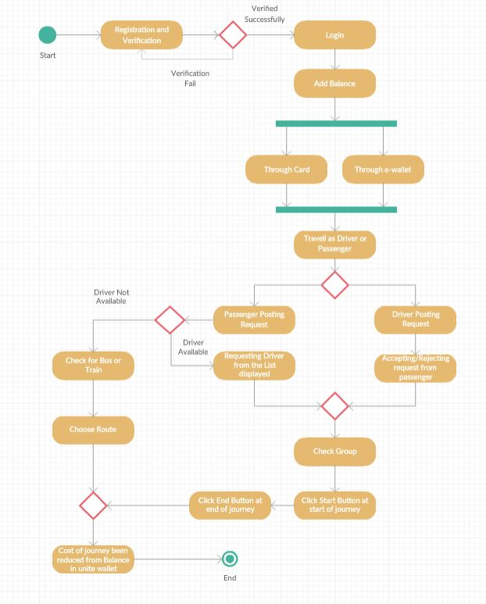

**FIGURE 10: ACTIVITY DIAGRAM**

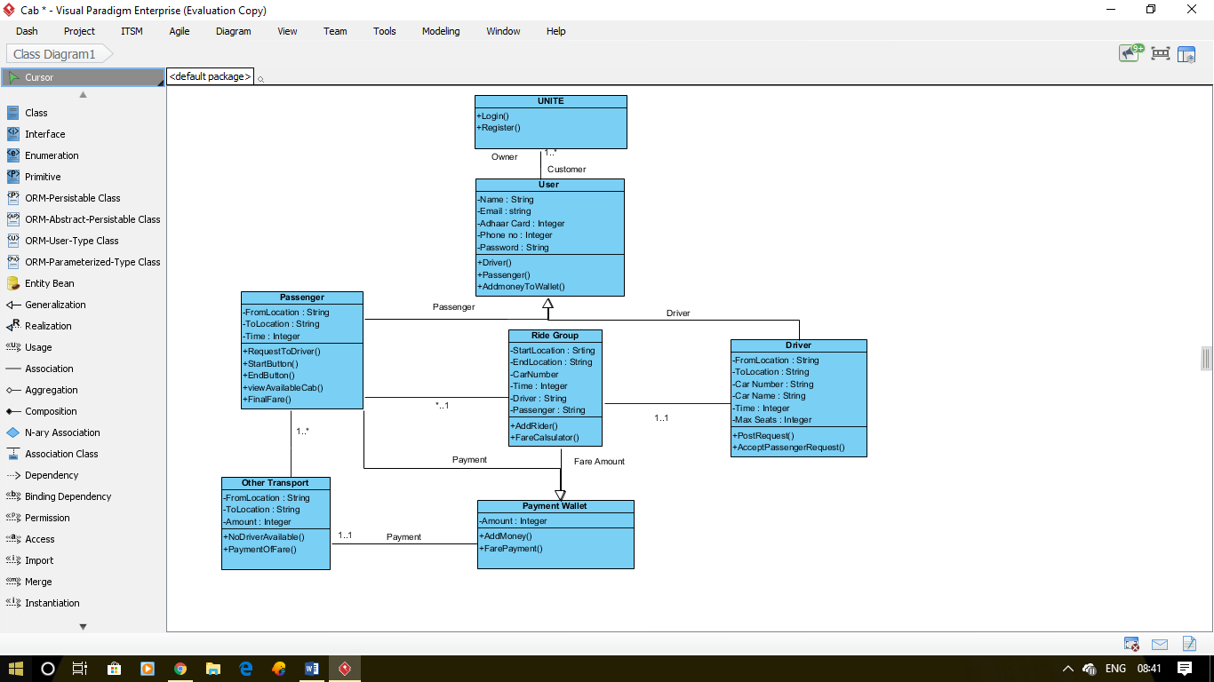

**FIGURE 11: CLASS DIAGRAM**

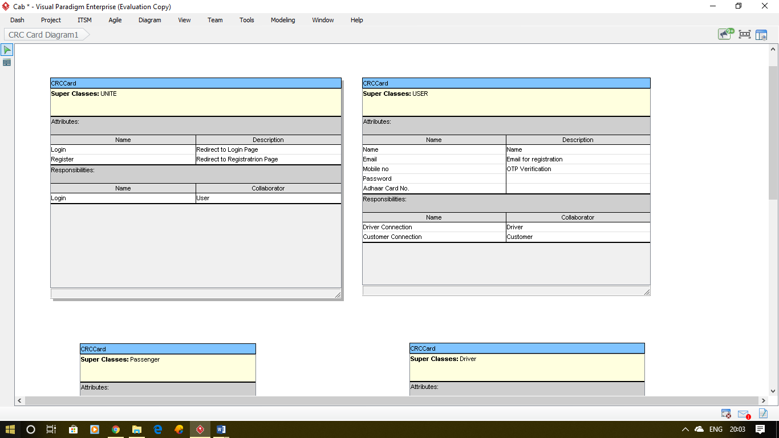



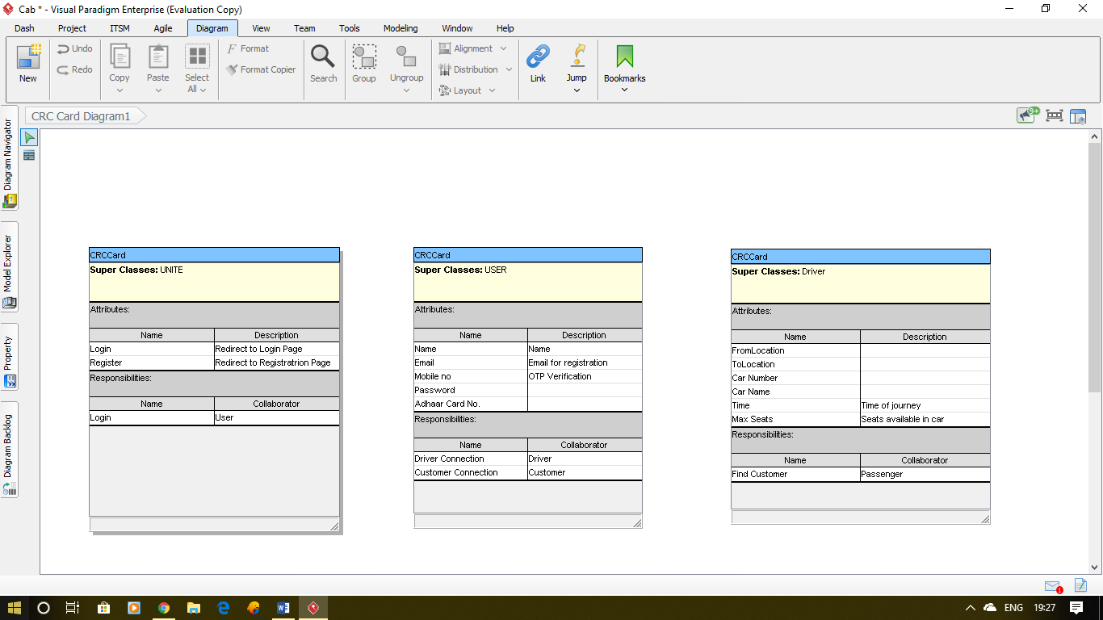

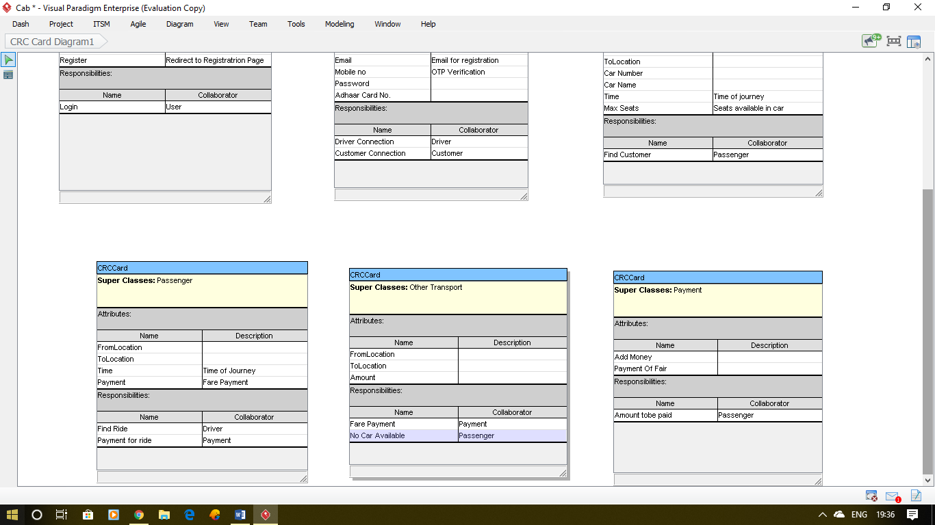





**FIGURE 12: CRC CARDS**

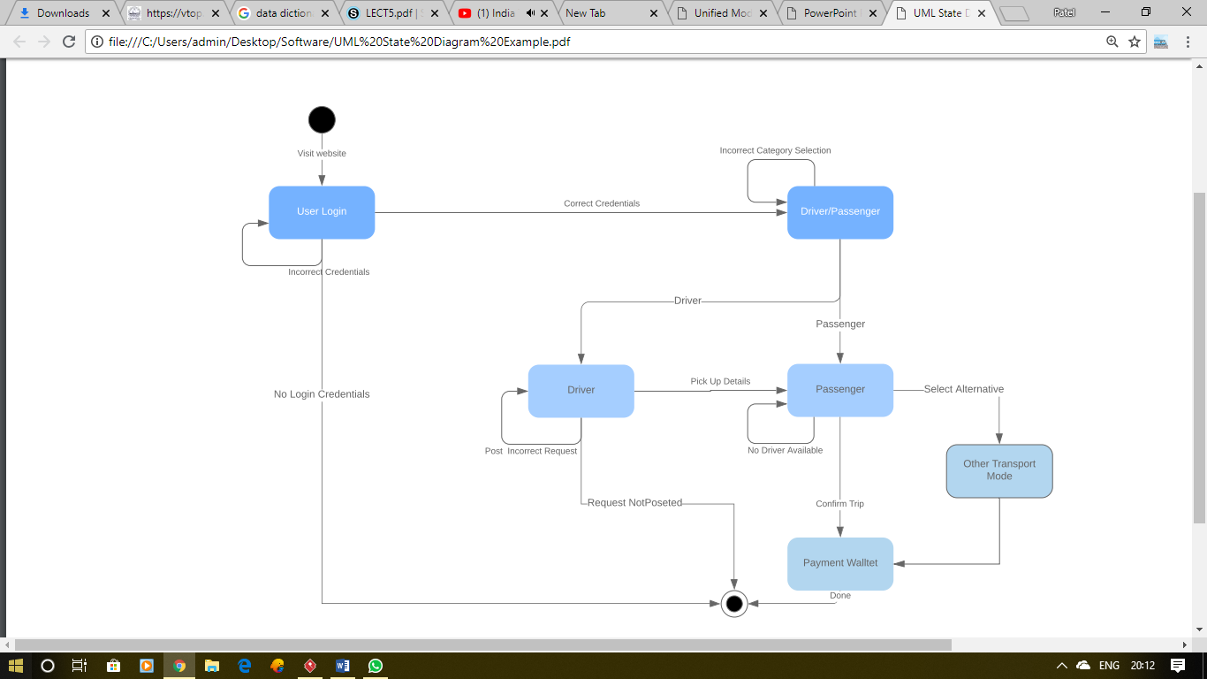

**FIGURE 13: STATECHART DIAGRAM**

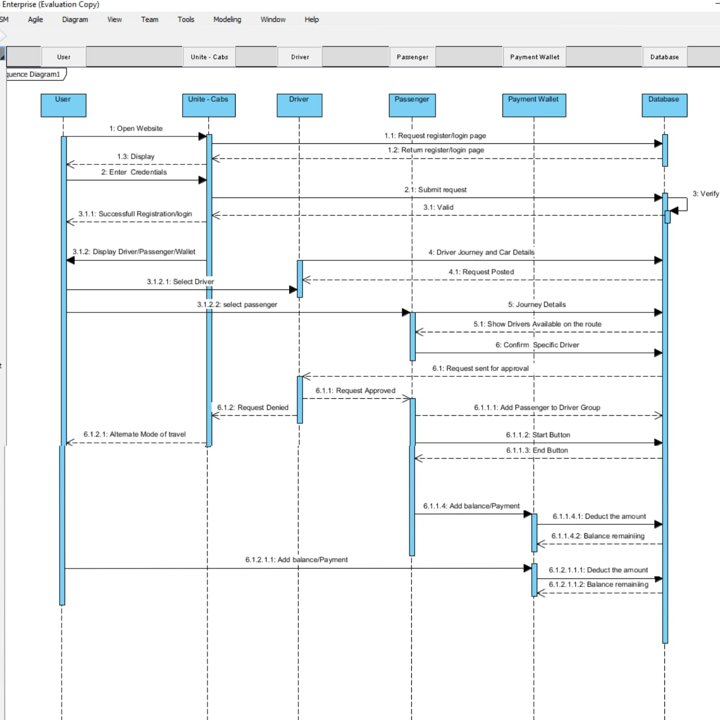

**FIGURE 14: SEQUENCE DIAGRAM**

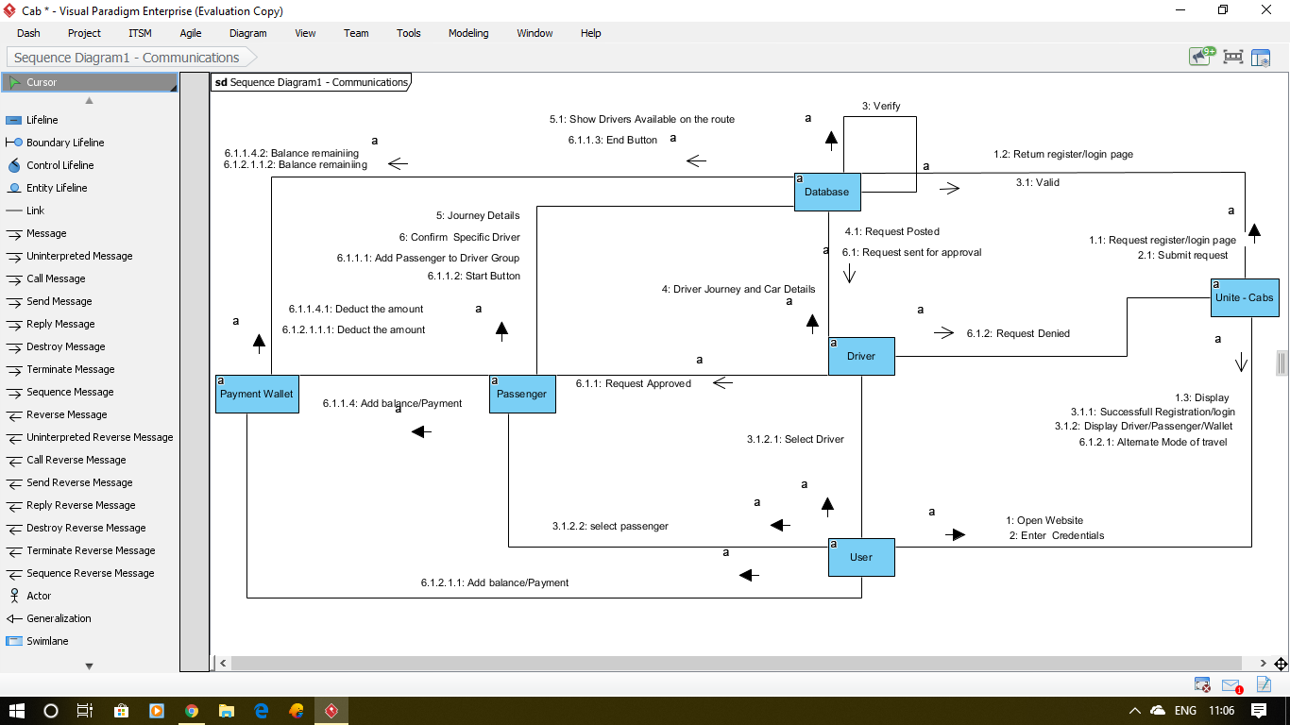

**FIGURE 15: COLLABORATION DIAGRAM**

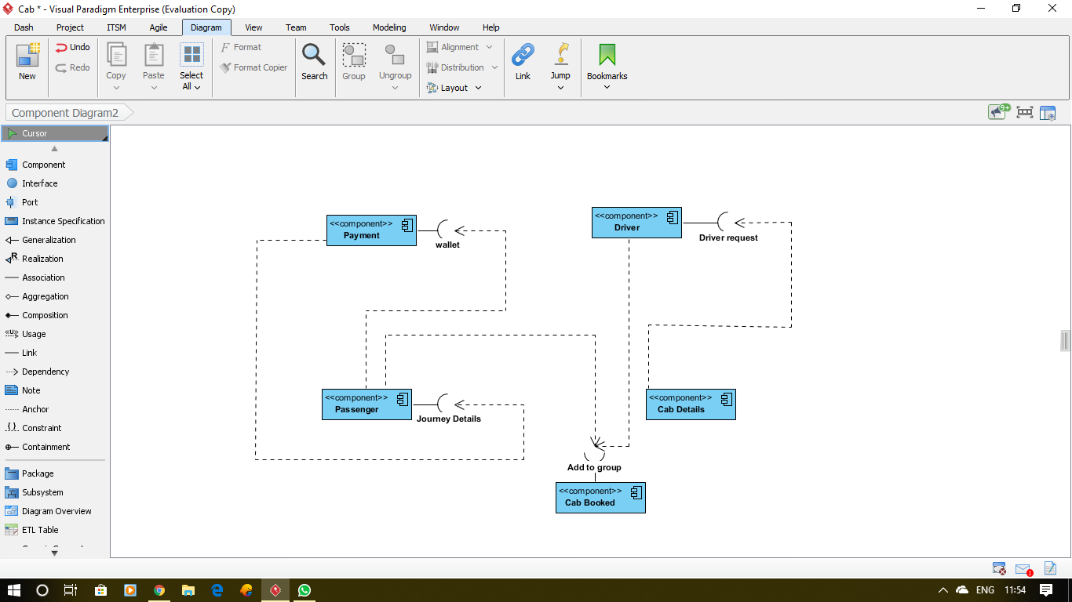

**FIGURE 16: COMPONENT DIAGRAM**

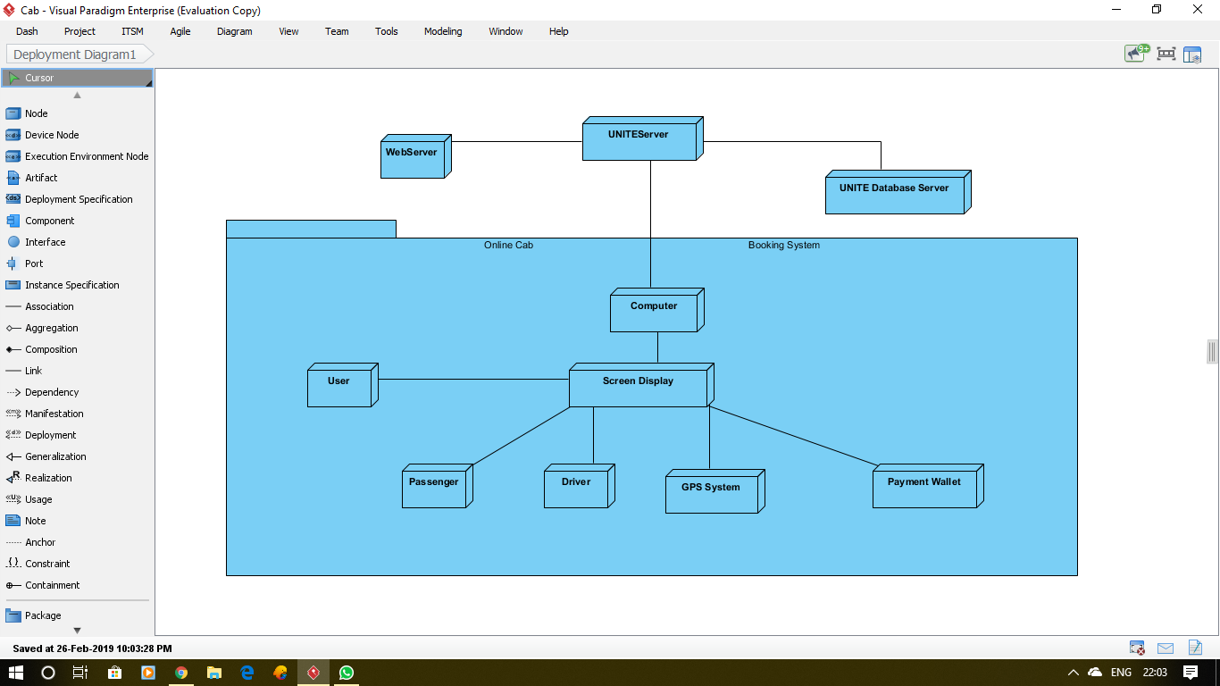

**FIGURE 17: DEPLOYMENT DIAGRAM**

**TABLE 6: TEST CASE TEMPLATES**

|  |  |
| --- | --- |
| Project Name: UNITE | |
| Test Case Template | |
| Test Case ID: 10 | Test Designed by: Patel Yash |
| Test Priority (Low/Medium/High): Med | Test Designed date: 14-03-2019 |
| Module Name: UNITE Login | Test Executed by: Patel Yash |
| Test Title: Verify login and Registration | Test Execution date: <Date> |
| Description: UNITE Login and Registration Verification |  |
|  | |
| Pre-conditions: User has valid username and password or User is opting For Registration | |
| Dependencies: | |

|  |  |  |  |  |  |  |
| --- | --- | --- | --- | --- | --- | --- |
| **Step** | **Test Steps** | **Test Data** | **Expected Result** | **Actual Result** | **Requirements Validated** | **Status (Pass/Fail)** |
| 1 | Navigate to login page | UNITE Home Page | User should be able to login | User is able to access home page | R1 | Pass |
| 2 | Redirect to Login or Registration | Click on Login or Registration | Redirect to Login or Registration Page | User is able to redirect | R1 | Pass |
| 3 | Provide valid username and password | Username:xyz@gmail.com  Password: 1234 | Login Sucessful | Successful Login | R1 | Pass |
| 4 | Provide Valid Mobile Number and Email For Registration | 8870066274  xyz@gmail.com | Send OTP | OTP Sent | R1.2 | Pass |
| 5 | OTP Authentication | 616071 | OTP Matched Redirect to Login | OTP Matched Redirect to login | R1.3 | Pass |

**Post-conditions:**

User is validated with database and successfully login to account. The account session details are logged in database.

|  |  |
| --- | --- |
| **Project Name: UNITE** | |
| **Test Case Template** | |
| **Test Case ID:** 11 | **Test Designed by:** Patel Pushpam |
| **Test Priority (Low/Medium/High):** High | **Test Designed date:** 14/03/2019 |
| **Module Name:** Driver posting | **Test Executed by:** Patel Psuhpam |
| **Test Title:** Driver Entering all the details | **Test Execution date:** <Date> |
| **Description:** Driver posting the request by entering the end and start location and also sharing the latitude and longitude and then posting the details |  |
|  | |
| **Pre-conditions:** Driver has to login to the application | |
| **Dependencies:** Driver location and start and end location | |

|  |  |  |  |  |  |  |
| --- | --- | --- | --- | --- | --- | --- |
| **Step** | **Test Steps** | **Test Data** | **Expected Result** | **Actual Result** | **Requirements Validated** | **Status (Pass/Fail)** |
| 1 | Navigate to posting page | Driver navigating to driver posting page | Driver can see the posting page and can enter the details | Driver see’s the posting page | R2 | Pass |
| 2 | Driver enter the source and destination | start Location: Bandra  end location: Dadar | Driver can enter the location from the displayed list | Driver is able to chose the location from the list | R2.1 | Pass |
| 3 | Driver Enter Car detail  a)Car name  b)Car Number  c)Max Seat  d)Time | Car name : Vento  Car Number : TNXX125  Max Seat:4  Time:12:00 pm | User entering the car details | User Enters the correct car details | R2.1 | Pass |
| 3 | Driver sharing their current location | Location of driver being traced | Driver’s latitude and longitude being taken | Driver’s latitude and longitude been taken | R2.2 | Pass |
| 4 | Post button working | On click the functionality is to be performed | Request Posted | Request posted | R2.2 | Pass |

**Post-conditions:**

Driver posting the request after entering the details and then navigated to home page

|  |  |
| --- | --- |
| **Project Name: UNITE** | |
| **Test Case Template** | |
| **Test Case ID:** 12 | **Test Designed by:** Psuhpam Patel |
| **Test Priority (Low/Medium/High):** High | **Test Designed date:** 14-03-2019 |
| **Module Name:** Passenger posting and requesting driver | **Test Executed by:** Pushpam Patel |
| **Test Title:** Passenger posting the request and sending request to join in car | **Test Execution date:** <Date> |
| **Description:** Passenger to add start and end location and passenger after posts the request they can see the all the driver present near to them based on their location |  |
|  | |
| **Pre-conditions:** Passenger has succesfully logged in and wants to travel. | |
| **Dependencies:** Passengers location and start and end location | |

|  |  |  |  |  |  |  |
| --- | --- | --- | --- | --- | --- | --- |
| **Step** | **Test Steps** | **Test Data** | **Expected Result** | **Actual Result** | **Requirements Validated** | **Status (Pass/Fail)** |
| 1 | Navigating to passenger posting page | Passenger to navigate to passenger page | Passenger to navigate to passenger posting page | Passenger to go to passenger posting page | R3.1 | Pass |
| 2 | Passenger can enter the data | Passenger can enter the start and end location | Passenger can enter the location from the displayed list | Passenger is able to chose the location from the list | R3.1 | Pass |
| 3. | Passenger sharing their current location | Location of passenger being traced | Passenger’s latitude and longitude being taken | Passenger’s latitude and longitude been taken | R3.1 | Pass |
| 4 | Navigate driver available page | Passenger Seeing available drivers | Passenger can see all the driver available | Passenger see’s all the available driver | R3.2 | Pass |
| 5 | Passenger sending request | The request been send to chosen driver | Request is been send to the driver and group is made | Request has been to chosen driver | R3.3 | Pass |
| 6 | Request button working | On click the functionality is to be performed | Request sent | Request sent | R3.3 | Pass |

**Post-conditions:**

Passenger posting the request and sending driver request to join his car based on his current location

|  |  |
| --- | --- |
| **Project Name: UNITE** | |
| **Test Case Template** | |
| **Test Case ID:** 13 | **Test Designed by:** Pushpam Patel |
| **Test Priority (Low/Medium/High):** High | **Test Designed date:** 14-03-2019 |
| **Module Name:** Driver accepting | **Test Executed by:** Pushpam Patel |
| **Test Title:** Driver to accept or reject the request | **Test Execution date:** <Date> |
| **Description:** When passenger sends the request to join the car based on the location the driver has the authority to either accept or reject it |  |
|  | |
| **Pre-conditions:** Passenger has to send the request | |
| **Dependencies:** Passengers selection and location | |

|  |  |  |  |  |  |  |
| --- | --- | --- | --- | --- | --- | --- |
| **Step** | **Test Steps** | **Test Data** | **Expected Result** | **Actual Result** | **Requirements Validated** | **Status (Pass/Fail)** |
| 1 | Navigate Request page | Driver post request | Driver can see all the requests send by the passenger | Driver see’s all the requests send by the passenger | R4 | Pass |
| 2 | Driver accepting | The request being accepted | The driver is accepting the request and group is made | Drive is able to accept the request and group is made | R4.1 | Pass |
| 3 | Driver rejecting | The request been rejected | If driver does not want to accept the request the remove the data | Driver doesn’t wanted to accept the data and data removed | R4.2 | Pass |
| 4 | Accept and Reject button working | On click the functionality is to be performed | Driver can accept or reject on clicking the buttons | Driver can accept or reject on clicking | R4.2 | Pass |
| 5 | Group is made | Whether the group is made or not | Group of all passenger and driver is made | Group is made | R4.2 | Pass |

**Post-conditions:**  Driver on Accepting the request group is made and on Rejecting the request the passenger request is removed

|  |  |
| --- | --- |
| Project Name: UNITE | |
| Test Case Template | |
| Test Case ID: 14 | Test Designed by: Patel Yash |
| Test Priority (Low/Medium/High): High | Test Designed date: 14-03-2019 |
| Module Name: UNITE Login | Test Executed by: Patel Yash |
| Test Title: Payment Deduction | Test Execution date: <Date> |
| Description: Payment After the Trip |  |
|  | |
| Pre-conditions: User is registered and has logged in successfully | |
| Dependencies: | |

|  |  |  |  |  |  |  |
| --- | --- | --- | --- | --- | --- | --- |
| **Step** | **Test Steps** | **Test Data** | **Expected Result** | **Actual Result** | **Requirements Validated** | **Status (Pass/Fail)** |
| 1 | Navigate to wallet page | Home page to wallet | User should be able to go to wallet | User is able to access wallet | R5 | Pass |
| 2 | Add Money Button | Select from the provided button | Money will be added | Money is added | R5.1 | Pass |
| 3 | Add Money Input | Writing the amount in the given space | Money will be added | Money is added | R5.1 | Pass |
| 4 | Automatic Deduction | Complete a ride | Fare will be automaticaly deducted | Fare id deducted | R5.2 | Pass |
| 5 | Deduction Notification | Display Amount Deducted And Balance Remaining | OTP Matched Redirect to Login | OTP Matched Redirect to login | R5.2 | Pass |

**Post-conditions:**

User has completed his trip and the amount of the fare is deducted.

DASHBOARD OF PROJECT

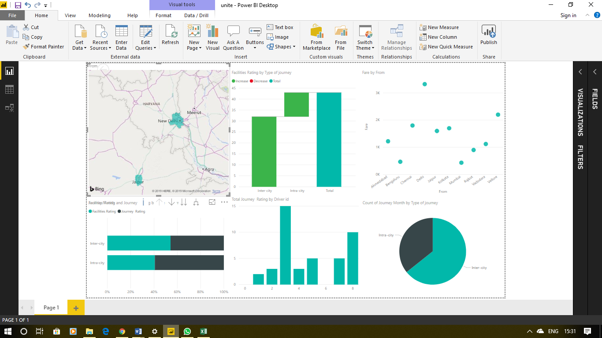

**FIGURE 18: DASHBOARD HOME**

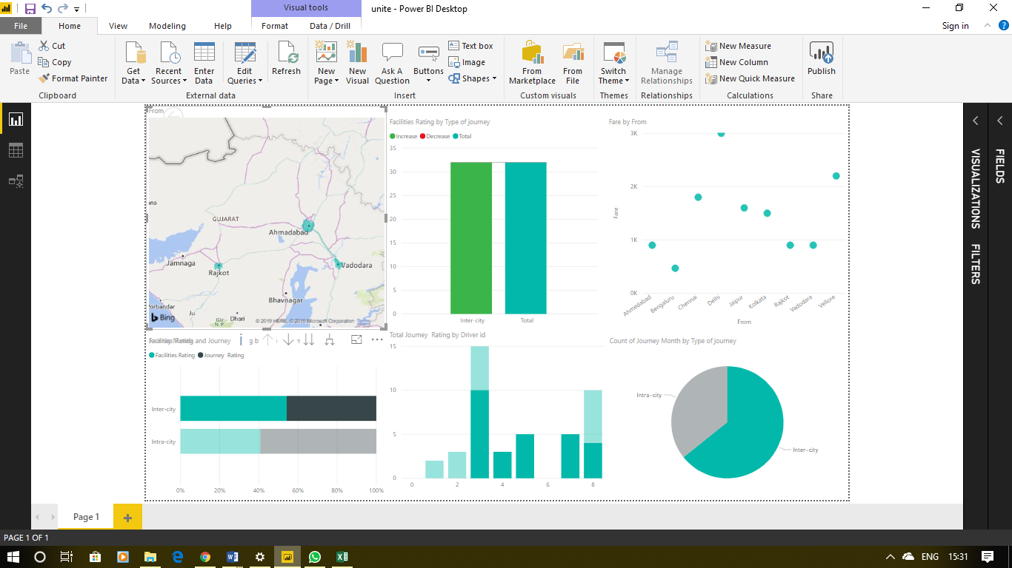

**FIGURE 19: DASHBOARD (FILTERED FOR INTER-CITY TRIPS)**

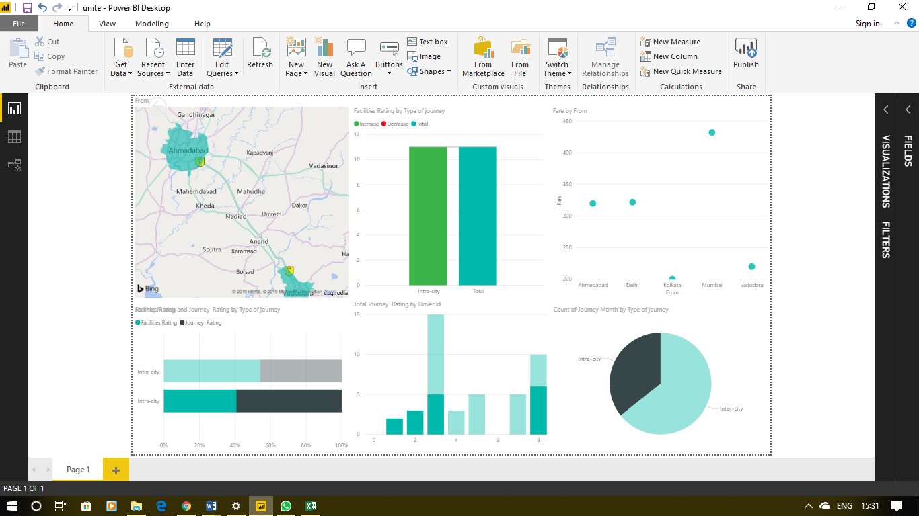

**FIGURE 20: DASHBOARD (FILTERED FOR INTRA-CITY TRIPS)**

* **USER MANUAL (WITH SCREENSHOTS)**

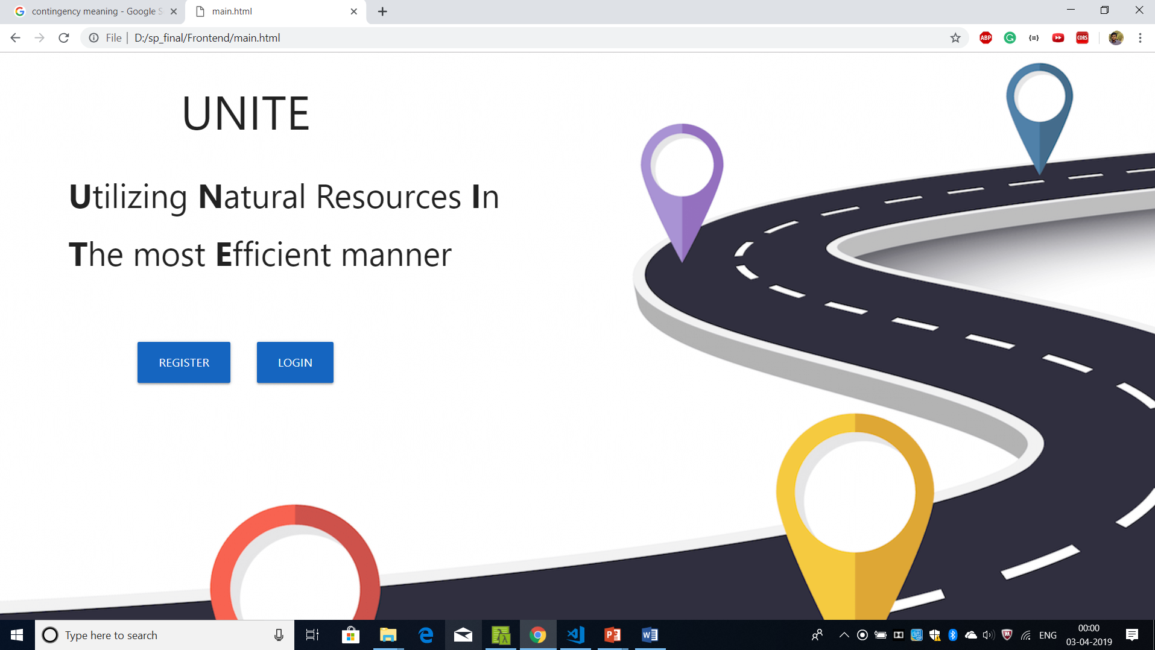

**FIGURE 21: MAIN PAGE**

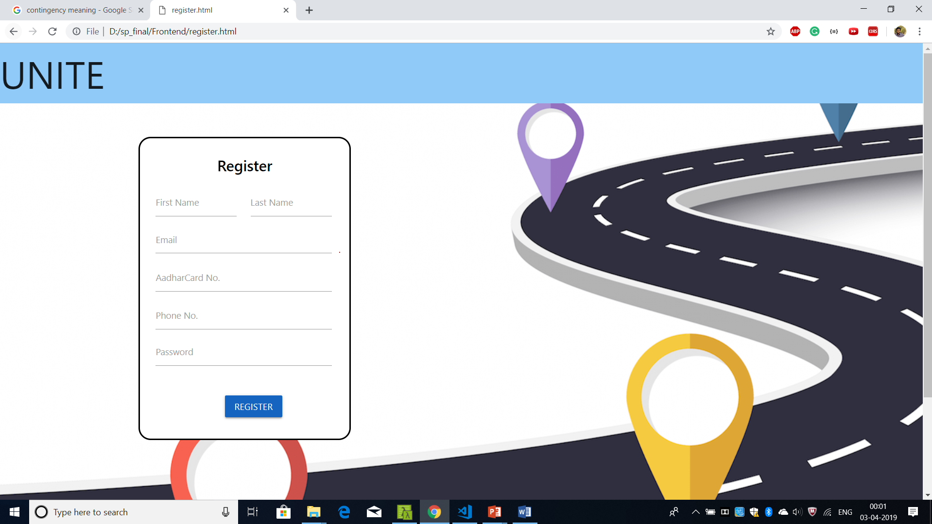

**FIGURE 22: REGISTER PAGE**

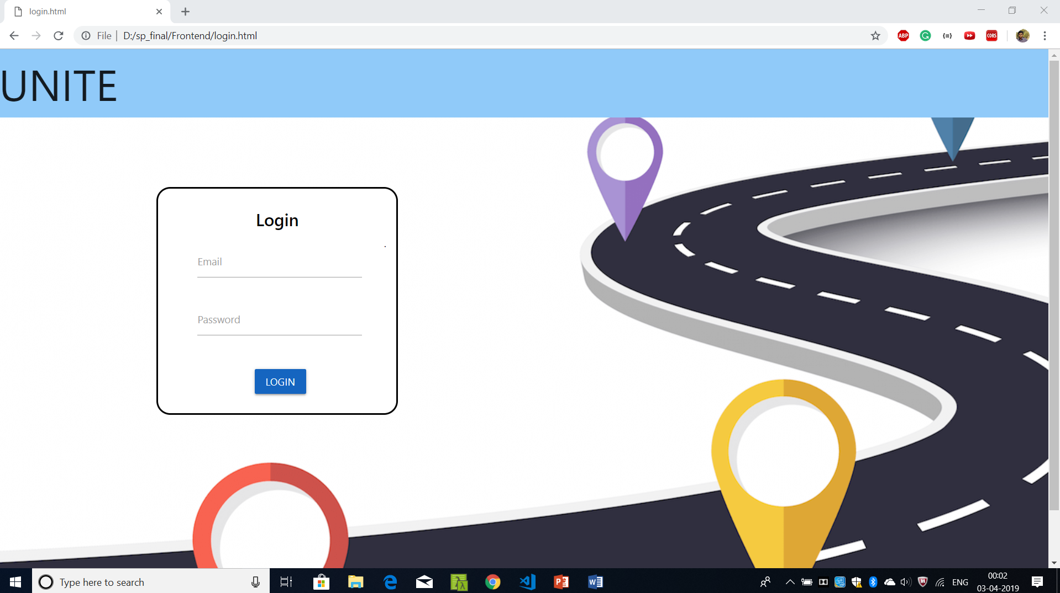

**FIGURE 23: Login Page**

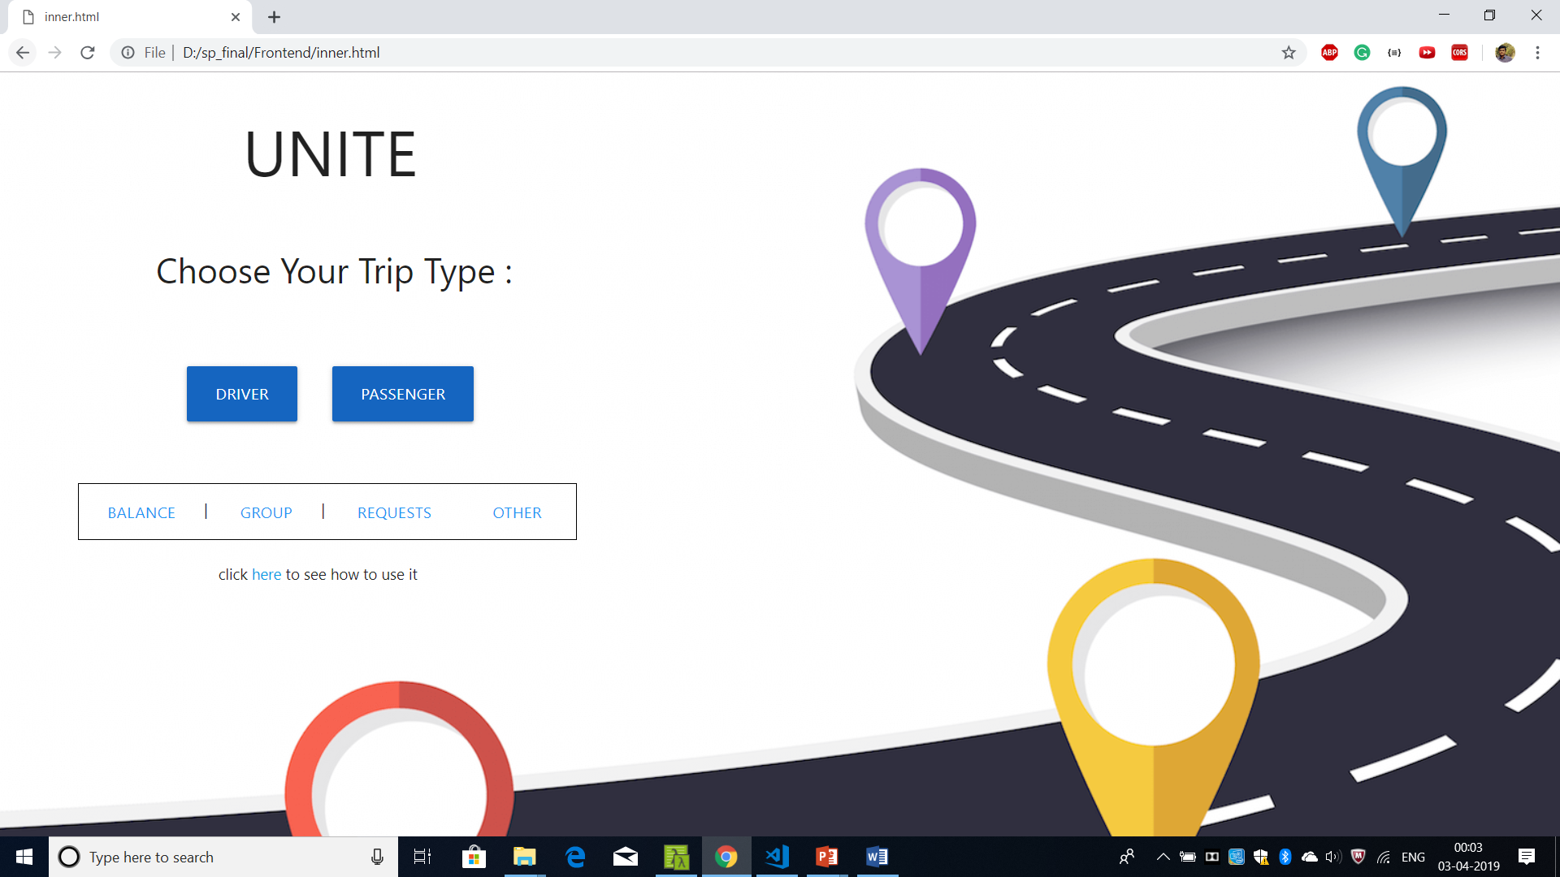

**FIGURE 24: Home Page**

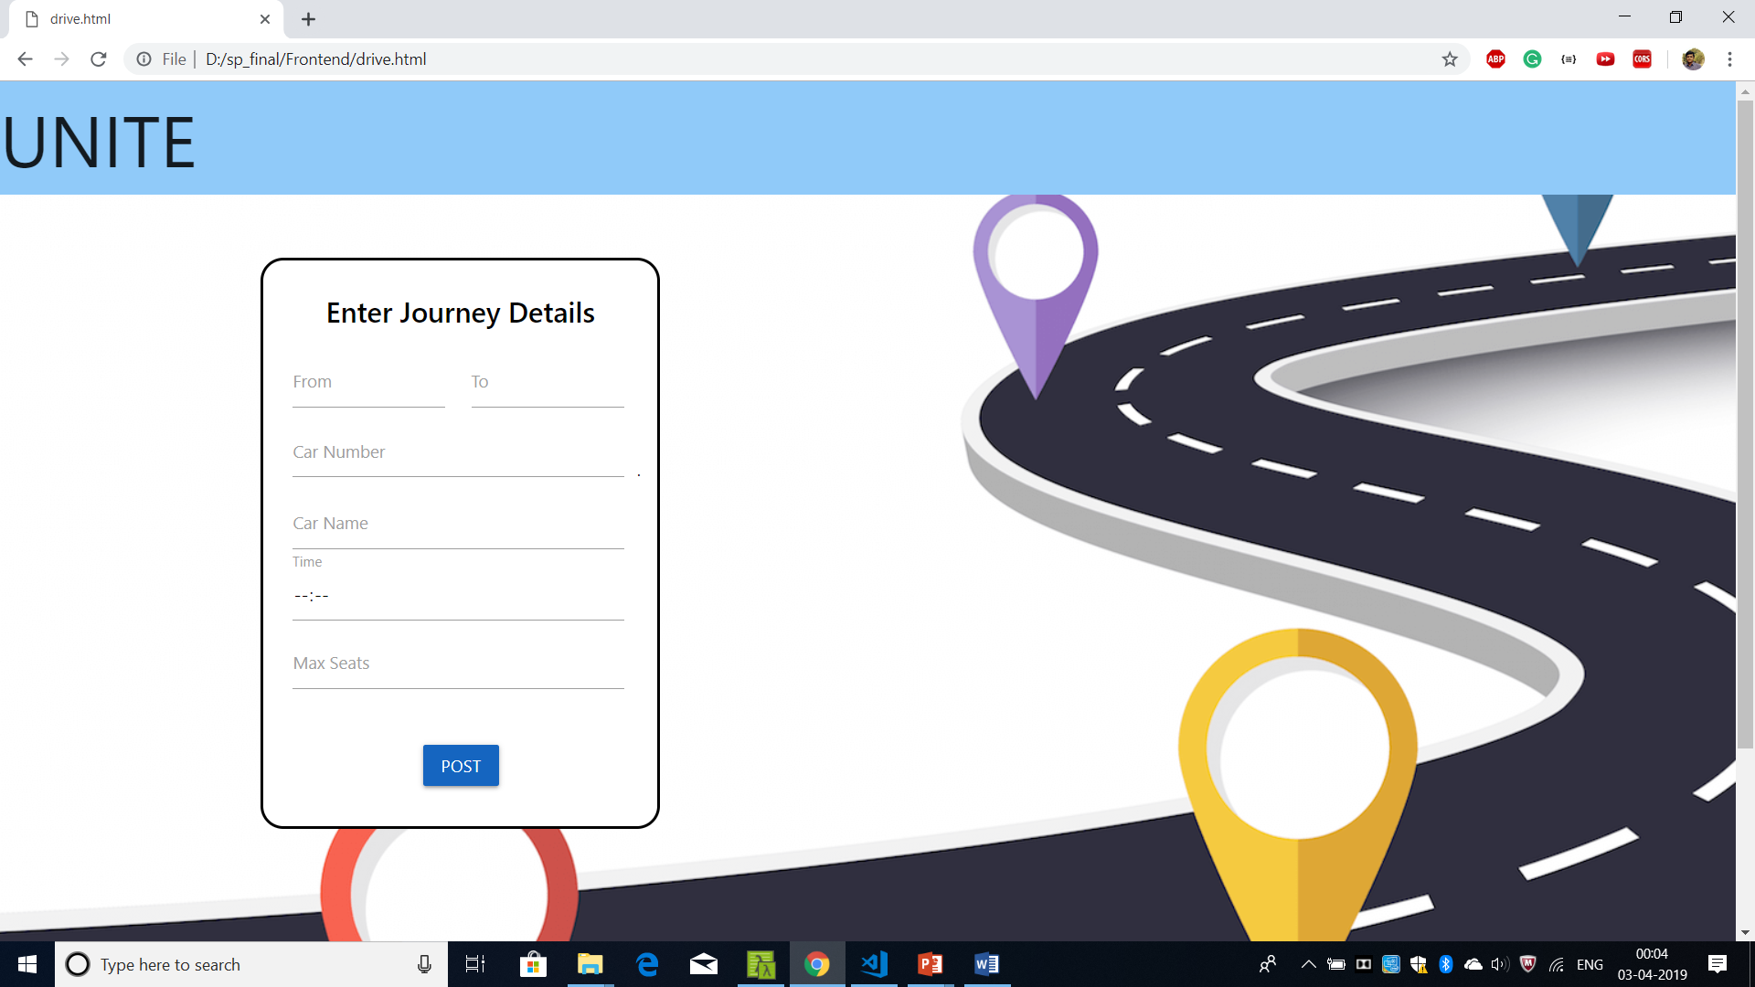

**FIGURE 25: Driver Posting Request**

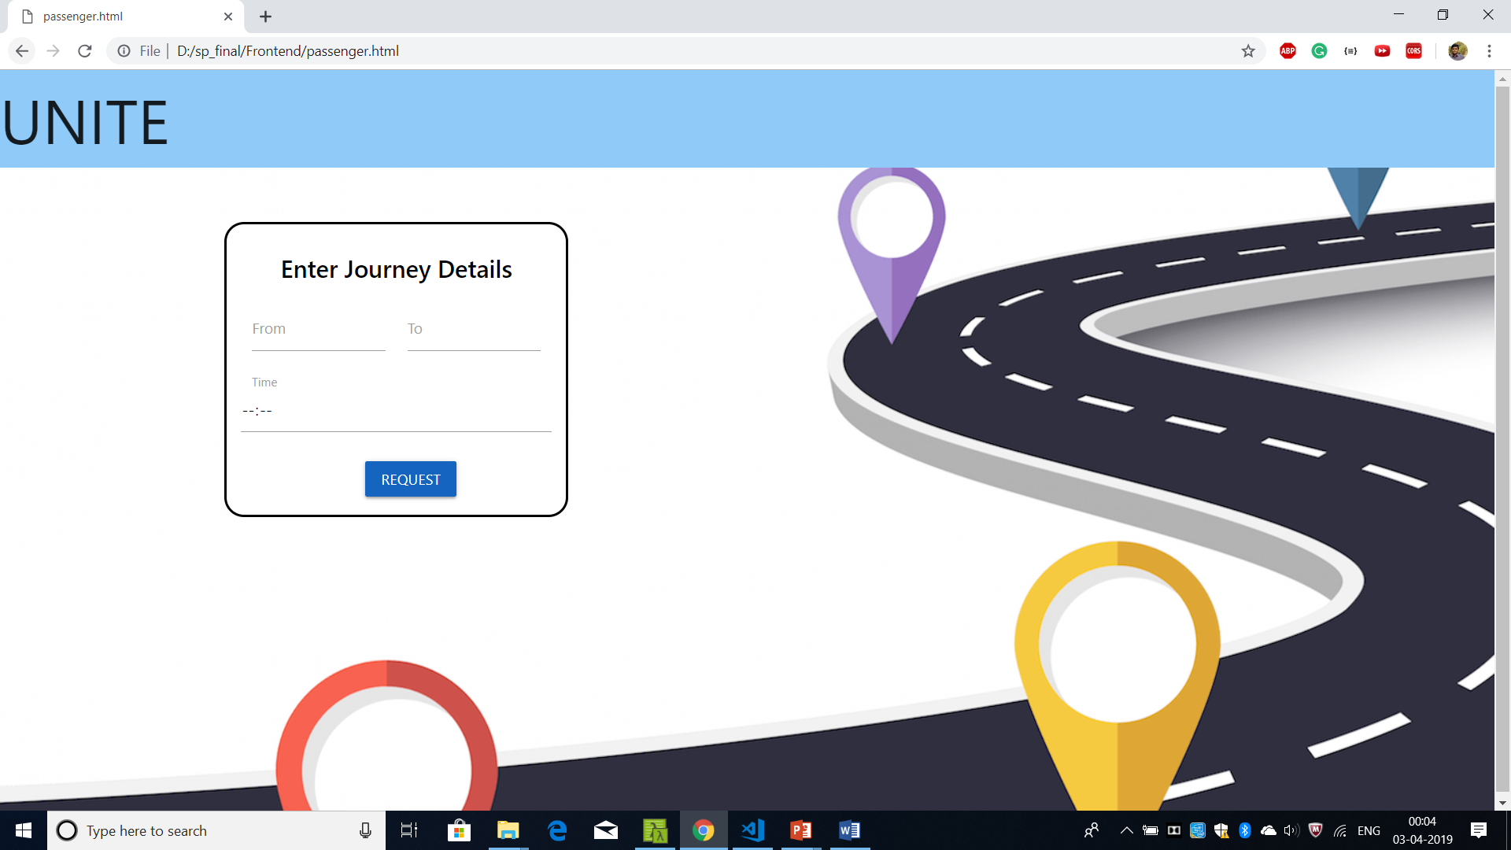

**FIGURE 26: Passenger Posting Request**

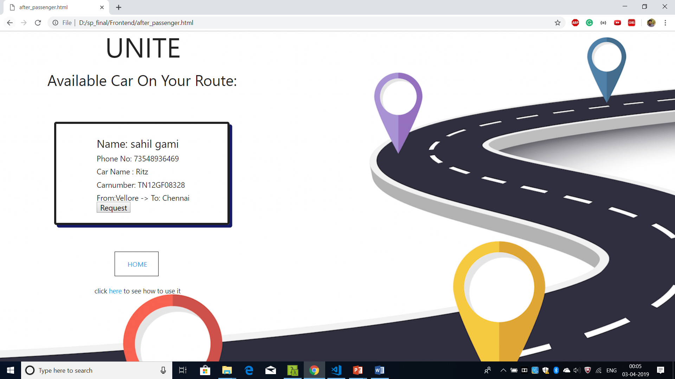

**FIGURE 27: Passenger Can See the available Drivers**

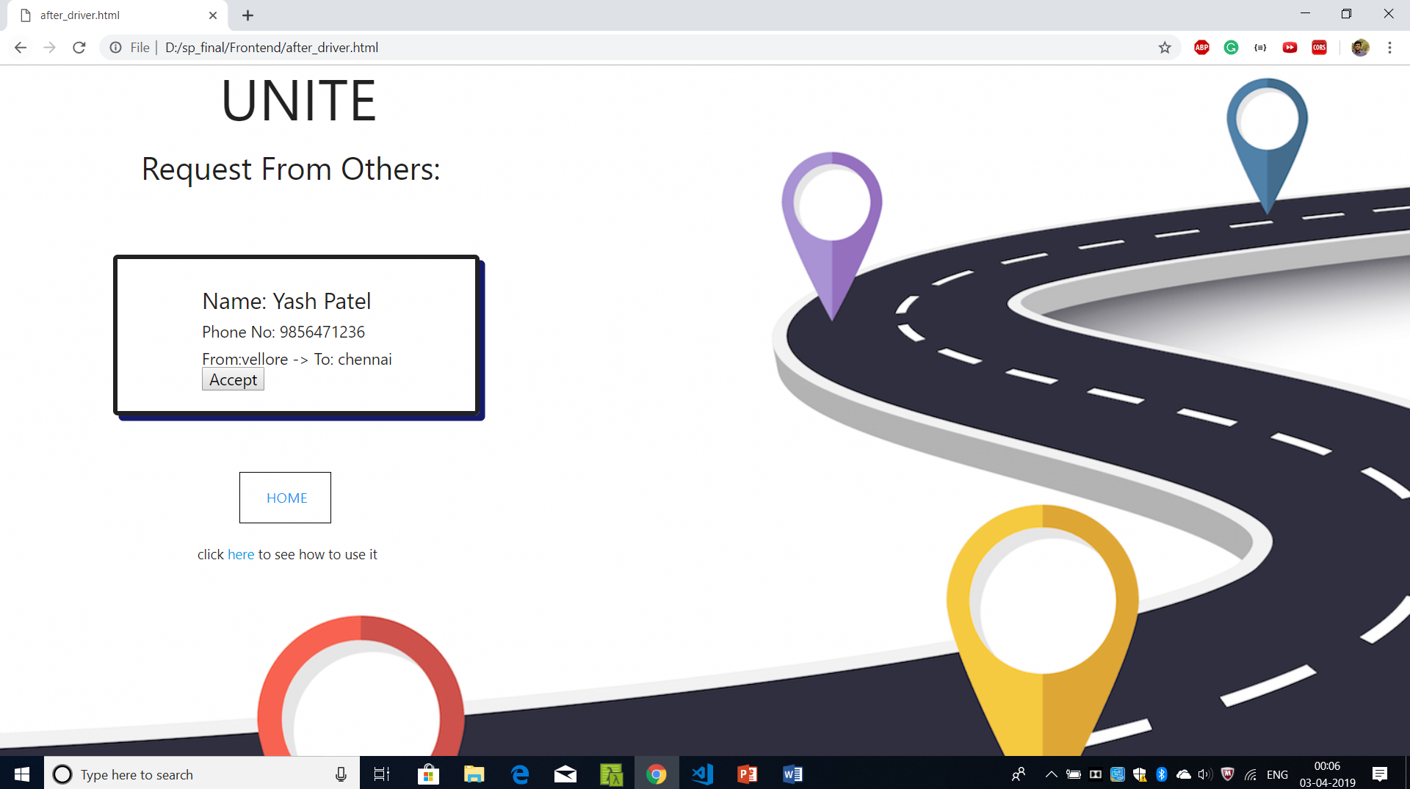

**FIGURE 28: Driver Seeing the Requests from Passengers**

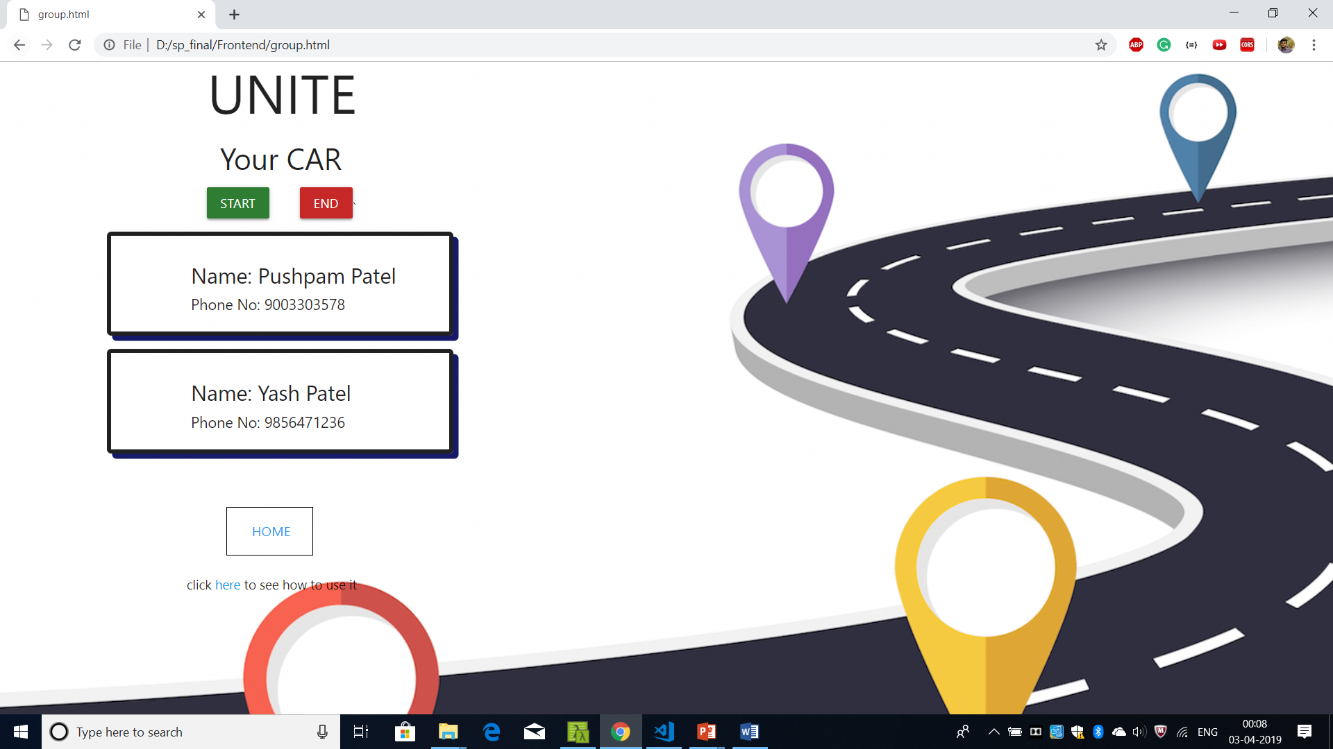

**FIGURE 29: Group Made**

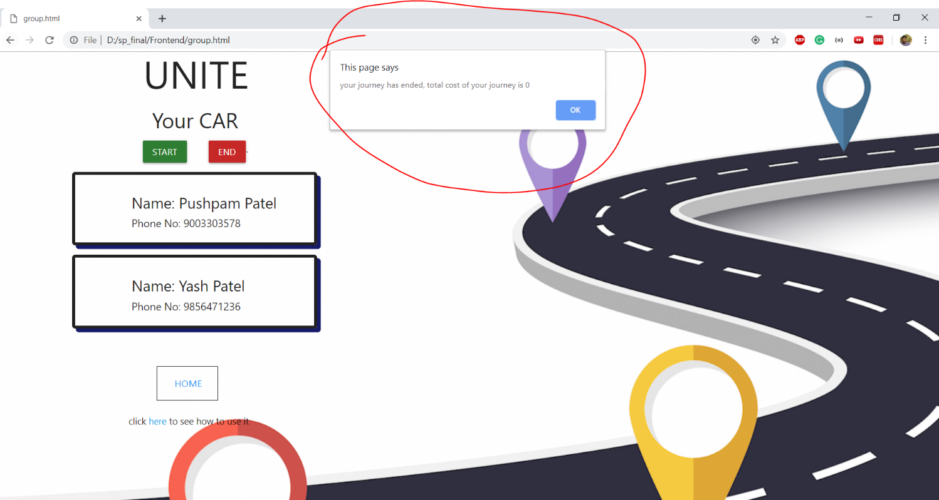

**FIGURE 30: Press Start At start of journey And End at end of Journey And Cost Displayed**

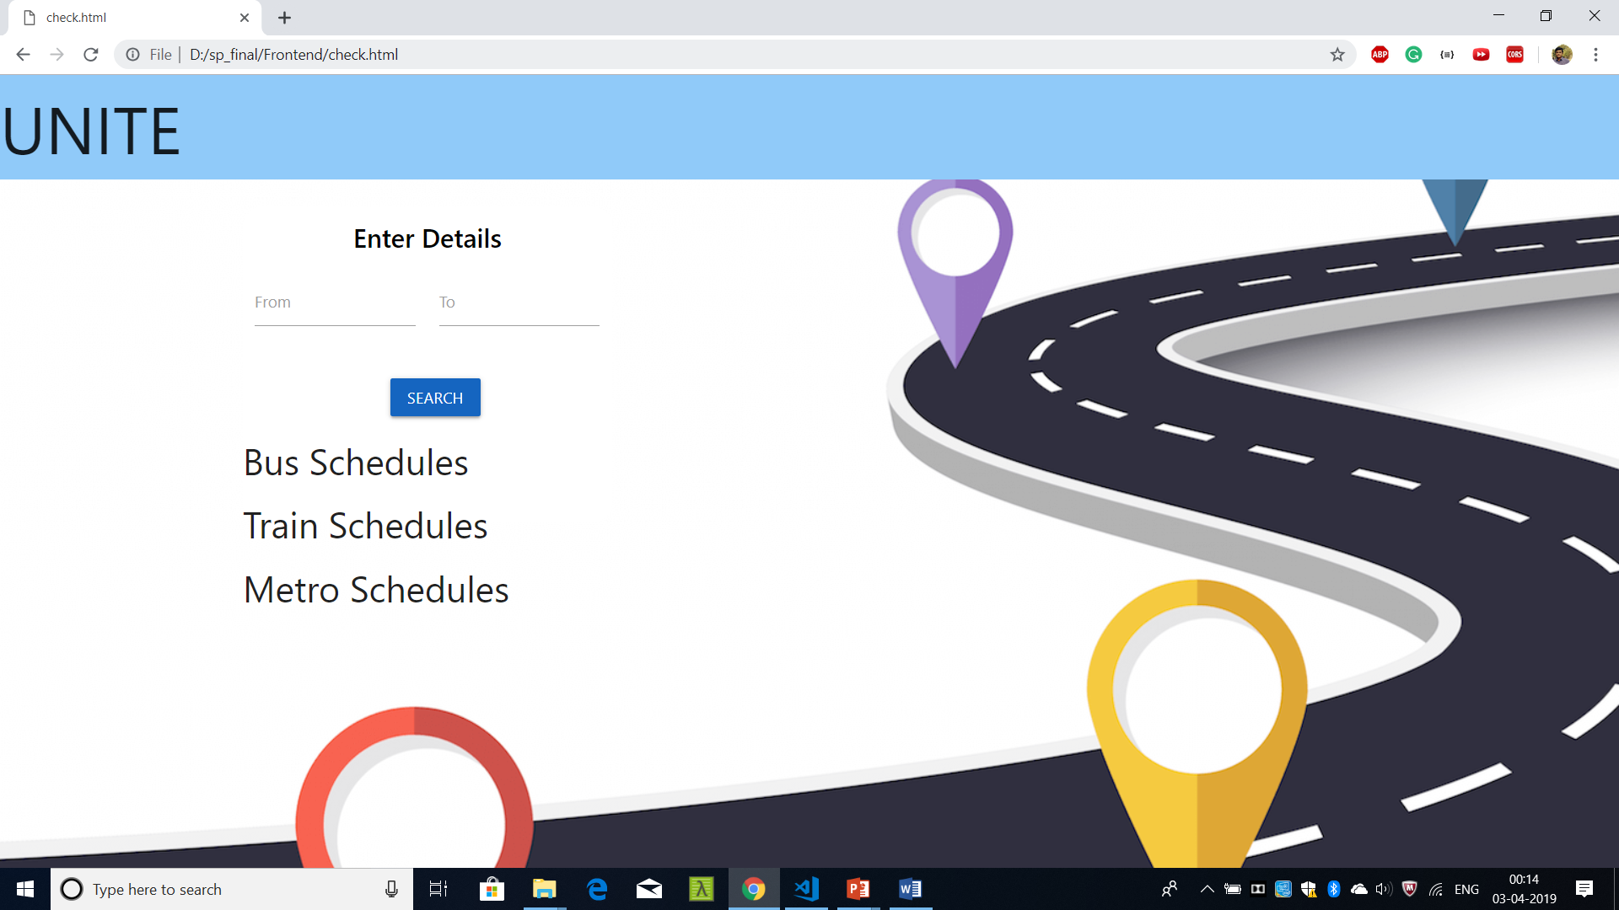

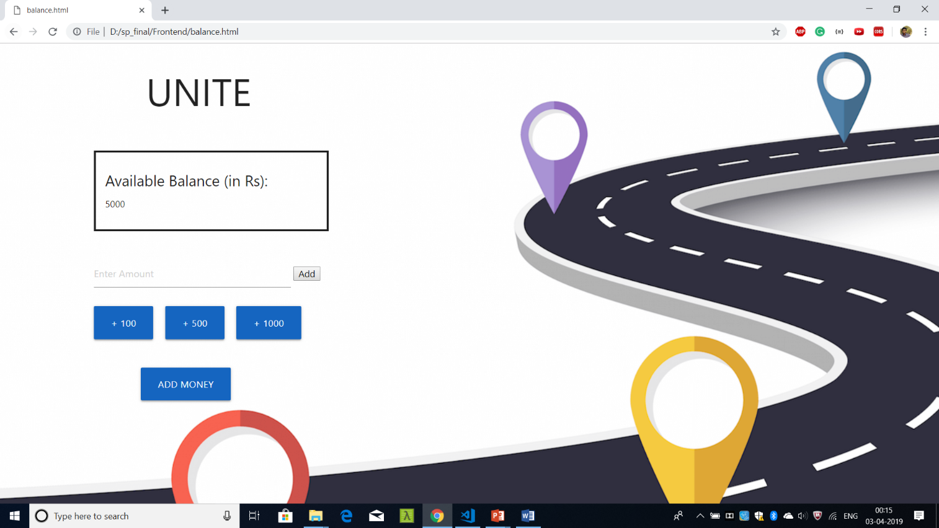**FIGURE 31: If No Driver is available [Use Other Transport]**

**FIGURE 32: Balance Page**